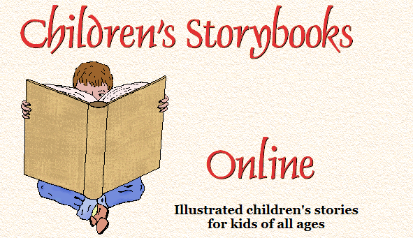
http://www.magickeys.com/books/index.html#books

http://www.ictgames.com/index.html

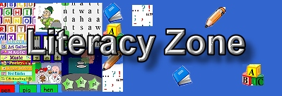
http://www.primaryhomeworkhelp.co.uk/literacy/

http://www.bbc.co.uk/bitesize/ks2/english/

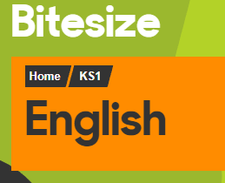
http://www.bbc.co.uk/education/subjects/zgkw2hv

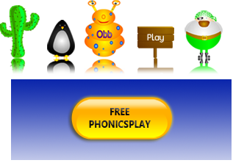
https://www.phonicsplay.co.uk/

http://www.barefootbooks.com/kids/animated-videos/

To help those children who are currently reluctant readers

http://www.lovereading4kids.co.uk/

http://www.cbcbooks.org/

