Science Task 2: Enquiry Type - Fair Test

Question
How can you change a paper spinner to make it accurately hit a target.
Carry out a fair test to explore what makes the spinner fall most accurately. Make a paper spinner and drop it from a height above the target. Does it land in the centre every time?
Make sure to only change one thing at a time so that you can say what improved the spinner. . Eg. The height dropped, number of wings, number of paperclips, size of paper, type of spinner.
- Cut an A4 piece of paper into 3 equal rectangles  - Cut and fold rectangle as shown below: Fold along dotted lines, cut solid lines  - Attach a small amount of mass to the bottom of your spinner eg. paper clip or blue-tac  - Draw a target zone on another piece of paper or place a target on the floor.  - Drop the spinner above the target and watch where it falls. | 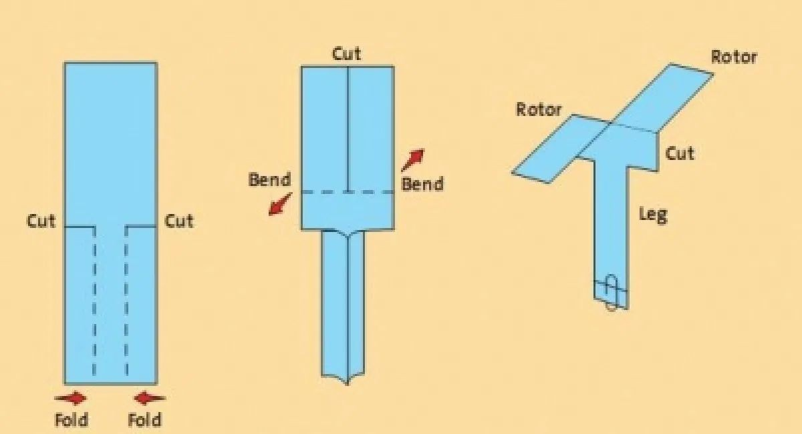

Younger Children | Older Children
Create a poster that explains what you found out. You could include:  - your equipment  - what was easy and hard to carry out  - your result | Write a report of your investigation showing your question, prediction, method and results.  When analysing your results, was your prediction correct? How could you have improved the investigation? What other investigations could you carry out?
Challenge | About this type of Scientific Enquiry
Imagine you are trying to advertise the spinner.  Create a leaflet about how to make the best spinner, making sure you use the evidence you have recorded to support your claim that it is the best type of spinner. | A fair test is when scientists look at all the different  things (variables) that could affect the result. Then only change one of them to see if it affects the outcome. By only changing one variable, scientists are able to confidently say that that caused the result. Eg. If they changed the number of wings and the mass of the  spinner they would not know if it was the mass or the number of wings that changed their result.  Fair testing is used to develop new medicines.

