Home learning
10.01.2020
To be back by Wednesday – 15th please

Maths- Play the times table game with a grown up at home. Please keep this game to play at home.
Spellings- Continue to focus on the spellings that were highlighted over Christmas.
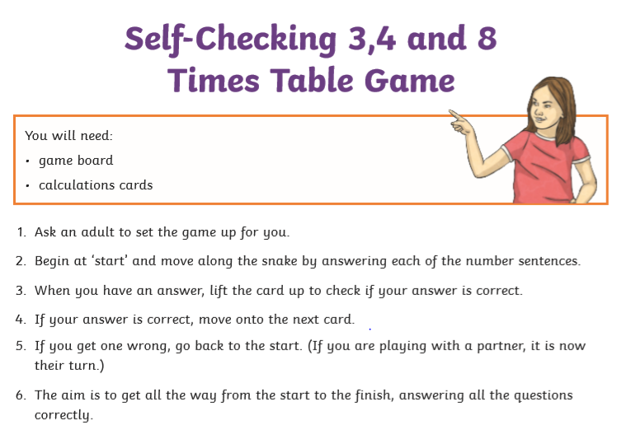
Grammar – Please complete the grammar sheet in your books.
