Practice Sheet Hot
Subtraction practice
Pick two snakes and calculate the difference in their length.
Work out as many as you can.

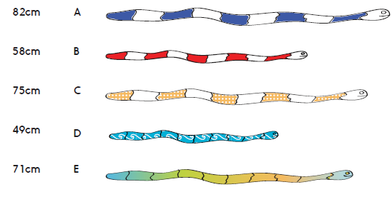

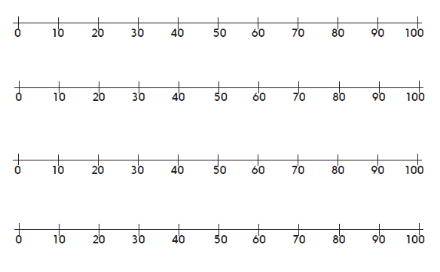

Which pair have the biggest difference? Which pair have the smallest difference?
Challenge
Snake F is 103cm long. How much longer is that than each of the other snakes?

