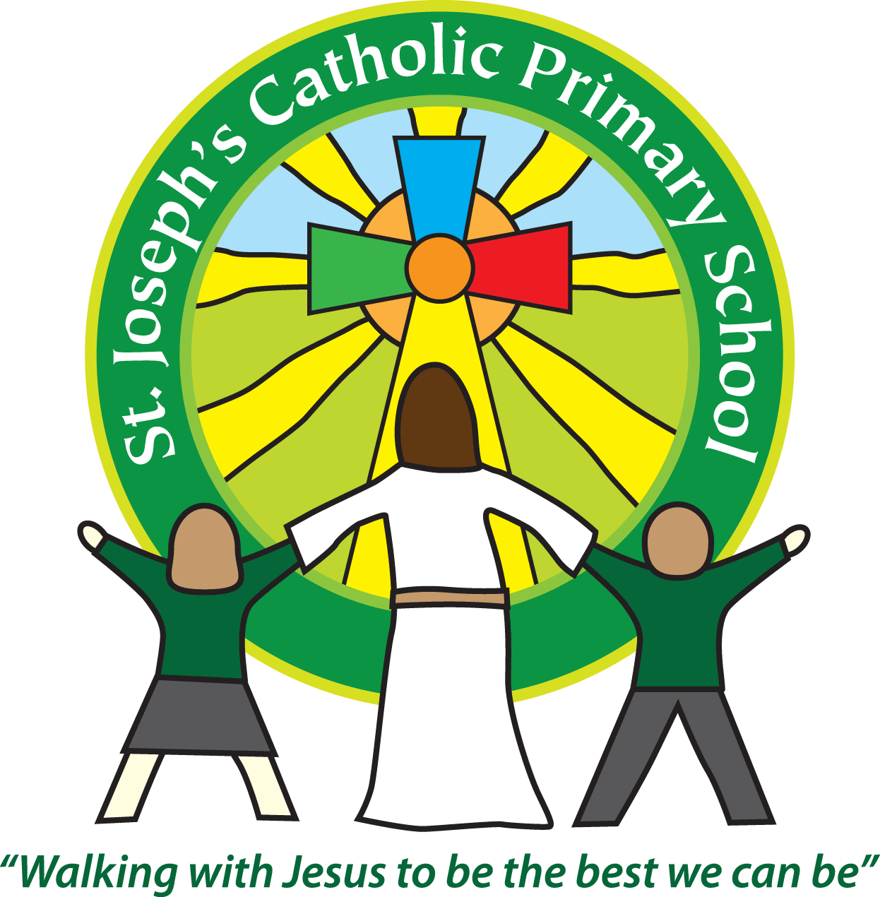
St Joseph’s Catholic Primary School Home Learning Pack
Class: Maple
Please find the suggested timetable. This is just a suggestion and you need to find what works for you and your child as we understand that everyone learns differently. Just to be clear – we are not expecting everyone to do all of the activities. We understand that our circumstances are all very different at the moment and that lots of you will be trying to juggle ‘home school’ and your own work as well as caring for elderly neighbours and family. There’s very little that needs to be printed out – lots of the resources can be viewed online and the work completed on plain paper. Please contact us at admin@stjo.uk and in the subject name it… For (Your Child’s teachers name and Class) if you need any further support. For example; For Mrs Jukes, Maple Class. This will help us to ensure your request is dealt with quickly.
Suggested Family Home Learning Timetable
This is a guide to help you establish a routine for your children – this is just a suggestion and you will need to adapt it to the needs of your family.
Time | Activity
Before 9.00 | Get up, washed, dressed, make beds and eat breakfast
9.00 – 9.30 | PE with Joe or family walk
9.30 – 9.45 | Drink and get ready for home learning
9.45 – 10.30 | English – writing, spelling or grammar activity from your home learning pack
10.30 – 11.00 | Break time - take a snack and drink outside if you can
11.00 – 11.45 | Maths – choose an activity from your home learning pack
11.45 – 12.30 | Creative time – draw, paint, sew, bake, do a job in the garden, stop-motion animation with lego / plasticine (the list is endless). Have a project that you can do a bit of everyday.
12.30 – 1.15 | Lunch – help to make it AND clear up behind it!
1.15 – 1.30 | Chores – do a job around the house e.g. put laundry away, tidy your room, vacuum or polish
1.30 – 2.00 | Quiet time – shared or independent reading
2.00 – 3.00 | Topic time – science / art / history / geography / music – choose a topic activity from the home learning pack
3.00 – 3.15 | Break time – take a snack and drink outside if you can
3.15 – 4.00 | Physical Activity – PE with Joe, family walk, yoga, Just Dance (look at Mrs Turner’s suggestions)

Maths |  | Activities | Resources
Day 1 | Can I use mental strategies for addition and subtraction? | Add and subtract near multiples of 10, 100 or 1000.  Questions and reminders about how to do this will be uploaded (see resources).  You can choose mild or hot (a bit like marvellous or mind-blowing) questions. There’s a help sheet if you get a bit stuck and an extension challenge for those who want it! | Wk1_Day1_Mental addition and subtraction strategies.pdf
Day 2 | Can I use the formal written method for subtraction? | Column method for subtraction (don’t forget to borrow if you need to!). Please lay your calculations out like we do in class with digits in each place value column lined up under each other. See the PDF for all the details. You don’t need to use the expanded version – year 5 moves onto the compact calculation – you will see what I mean when you read the activity instructions. | Wk1_Day2_Written (vertical) subtraction.pdf
Day 3 | Can I use counting up to solve subtraction problems? | This activity include some word problems – make sure you read them carefully. All the answers are included, so you can mark your work and make any corrections. Remember: making mistakes is not a problem – especially if you go back and figure out where you went wrong as that’s how you learn! | Wk1_Day3_Counting up to subtract.pdf
Day 4 | Can I use the column method to add decimals? | Remember: ALWAYS line up the decimal point! | Wk1_Day4_Column addition of decimals.pdf

English |  | Activities | Resources
Day 1 | Can I vary the position of adverbials in a sentence? | Read the instructions on the first page of the PDF. These will tell you what you need to do.  There’s a story to read, some work on adverbials and then you will write the next paragraph of the story about what might happen next.  Finally, there are some additional activities to do for fun! | Year 5 Day 1.pdf
Day 2 | Can I revise past and present tenses? | Instructions are on the first page again.  Read the story, think about what you discover about the characters in the story. Then there are some verb tense activities for you to follow and a paragraph to write about what might happen next. | Year 5 Day 2.pdf
Day 3 | Can I ask questions about a text to help my understanding? | Read the story, Hunted. Think about what you like / dislike and whether there are any puzzles or patterns you can identify. What unanswered questions do you have? Read the list of unanswered questions provided and see if you can answer any. Your task is to write a prequel (a story before the one you’ve just read). It should answer some of those unanswered questions – all the instructions are in the PDF. | Year 5 Day 3.pdf
Day 4 | Can I add extra information to a sentence using parentheses? | You are going to read some poetry today to make a change! Follow the instructions in the PDF. | Year 5 Day 4.pdf

Suggested Reading Activities
Please, can I encourage you to keep reading (and quizzing if possible) as this is the very BEST thing you can do to support your progress in learning. Read fiction (story) books, newspapers, magazines, comics, non-fiction texts (about real stuff) – anything will help. Got an encyclopaedia at home? Learn a new fact about the world everyday – create a notebook and fill it with interesting facts, adding detail by drawing pictures or researching more about it online. Your brain will soon be the size of Britain!!
You should all be aiming for AT LEAST 20 minutes of reading a day! Mrs Taylor-Bashford has sent links to websites to support you reading at home.
Spelling
Year 3/4
different
difficult
disappear
early
earth
eight
eighth

Year 5/6
curiosity
definite
desperate
determined
develop
dictionary

Use a dictionary (online is fine) to find out what these words mean, use them in a sentence and use the cover, write, check method to learn how to spell them. Get someone at home to test you like we do in class.

Varied activities of Science, Music, Topic (History, Geography, Art) and R.E
 |  | Activities | Resources
Day 1 | Can I describe the Earth’s structure? | - Read information provided  - Complete Plate Tectonics Jigsaw  - Choose one of the experiments in the booklet attached and have a go (you may need to do these OUTSIDE!). Take a photo or draw a diagram (and label it) of your experiment and write about what you observed happen and explain what this shows us about what happens in a real volcano. The notes with each experiment will help you but don’t just copy – make sure you explain in your own words – this will help you learn! | Topic Lessons Week 1.doc  Tectonic Plates Jigsaw.pdf  Volcano Experiments.pdf  Scissors, glue stick  Some kitchen cupboard ingredients
Day 2 | Can I draw and correctly label a diagram to show forces at work? | We had just started work on forces in science and this is something you can continue at home. There is lots of information about this topic on the BBC Bitesize website, here: https://www.bbc.co.uk/bitesize/topics/znmmn39  Remember, a force is a push a pull or a twist. For example, gravity is a force which pulls an object towards the centre of the Earth. Other forces include:  - friction – the resistance of two surfaces which are in contact with each other (this is a push force)  - air resistance – is a type of friction and is caused by air pushing against an object  Activity 1: Force diagrams – forces and the direction they are acting in are shown by arrows on a diagram. There are several forces at work. If the object is moving, the forces acting in the direction of travel are larger than the friction forces slowing it down. For example, when an aeroplane is flying through the air, the thrust from the engine provides a greater force than the air resistance (or drag). When an object is stationary, the forces are balanced.  lift  thrust  gravity  air resistance (drag)  Draw a force diagrams to show:  - a parachutist floating down through the air  - a ship moving across the sea  - you sitting still on the floor | Paper, pencil, ruler and pen for labelling
Day 3 | Can I explore the good news of the Easter story? | Read the story of Easter Sunday in the bible (John Chapter 20). The garden where Jesus was buried was a place of sadness and sorrow but became a place of great joy. This is the good news of Easter – Jesus turns our sadness into joy! Create a joy-filled Easter garden to help you and your family reflect on the good news of the Easter story. You could create one in a shoe box with paper flowers (like the origami daffodils – see day 4) or a plant a real one outside.  https://www.biblegateway.com/passage/?search=John+20&version=NIV  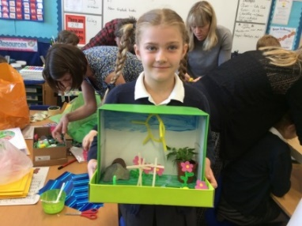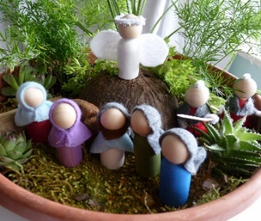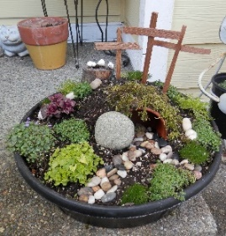 | Craft or gardening materials  Bible (online link in instructions)
Day 4 | Can I recreate a famous piece of art using collage? | 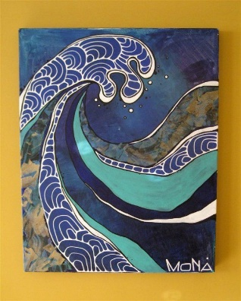  Hokusai is a famous Japanese artist (he made an appearance in Kensuke’s Kingdom). He is best known for his 36 views of Mount Fuji which includes perhaps his most famous piece: The Great Wave. See the worksheets attached for your task which is to create a collage of one of these 36 views! Here is an example of a collage of The Great Wave. You can use scraps of coloured paper, pages from magazines and even newspaper – whatever you can find!  Just for fun activity: Origami is a Japanese tradition – you might like to have a go (you could add some daffodils to your Easter Garden or send some to an elderly neighbour or someone in your family who you can’t go and visit at the moment). See the sheets below which give instructions on how to create a daffodil, crane or butterfly. There are lots of other ideas online if you want to explore further. | Hokusai Collage Task.doc  Hokusai-Examples.doc  Butterfly Origami.pdf  Daffodil Origami.pdf  Crane Origami.pdf  Scrap paper from magazines, newspaper, old birthday cards!  Glue stick and scissors.  Coloured paper for origami crafts.

