Topic – Our Violent Earth
Our topic this term is ‘Our Violent Earth’ and explores volcanoes (did you know I wanted to be a volcanologist when I grew up?!) and earthquakes and how they effect the lives of people around the world. Before we can understand why volcanoes and earthquakes happen, we need to understand a bit about the structure of the earth. There’s lots online about this (BBC Bitesize is helpful) but here are a few notes to help you get started. If you wanted to create a topic booklet, you could print these images out and stick them in. Make sure you look at them carefully and read all the labels!

Activity: The Earth’s Structure
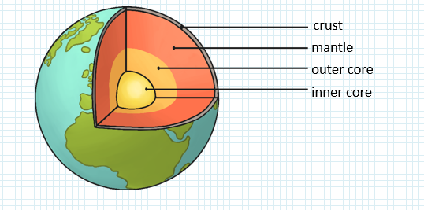

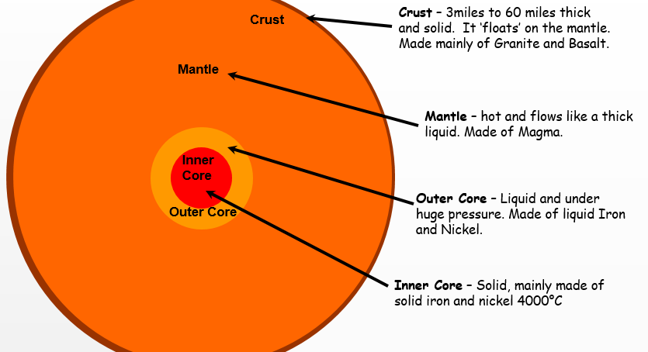

The Earth’s crust (outer layer) is not one solid piece, but it is made up of sections called tectonic plates. These fit together like the pieces of a jigsaw:
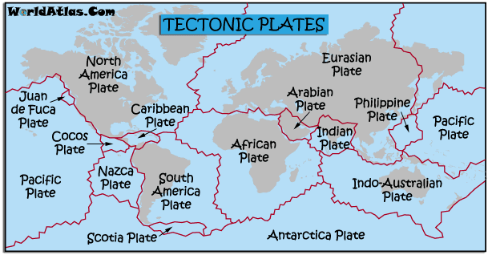

Your first task is to create a tectonic plate jigsaw using the worksheet attached – see Tectonic Plate Jigsaw.pdf.
If you wanted to know more, so some research about how and why these plates move – it has something to do with convection currents!

Activity 2 – Volcano experiments. Choose one of the experiments in the booklet attached and have a go (you may need to do these OUTSIDE!). Take a photo or draw a diagram (and label it) of your experiment and write about what you observed happen and explain what this shows us about what happens in a real volcano. The notes with each experiment will help you but don’t just copy – make sure you explain in your own words – this will help you learn!

