

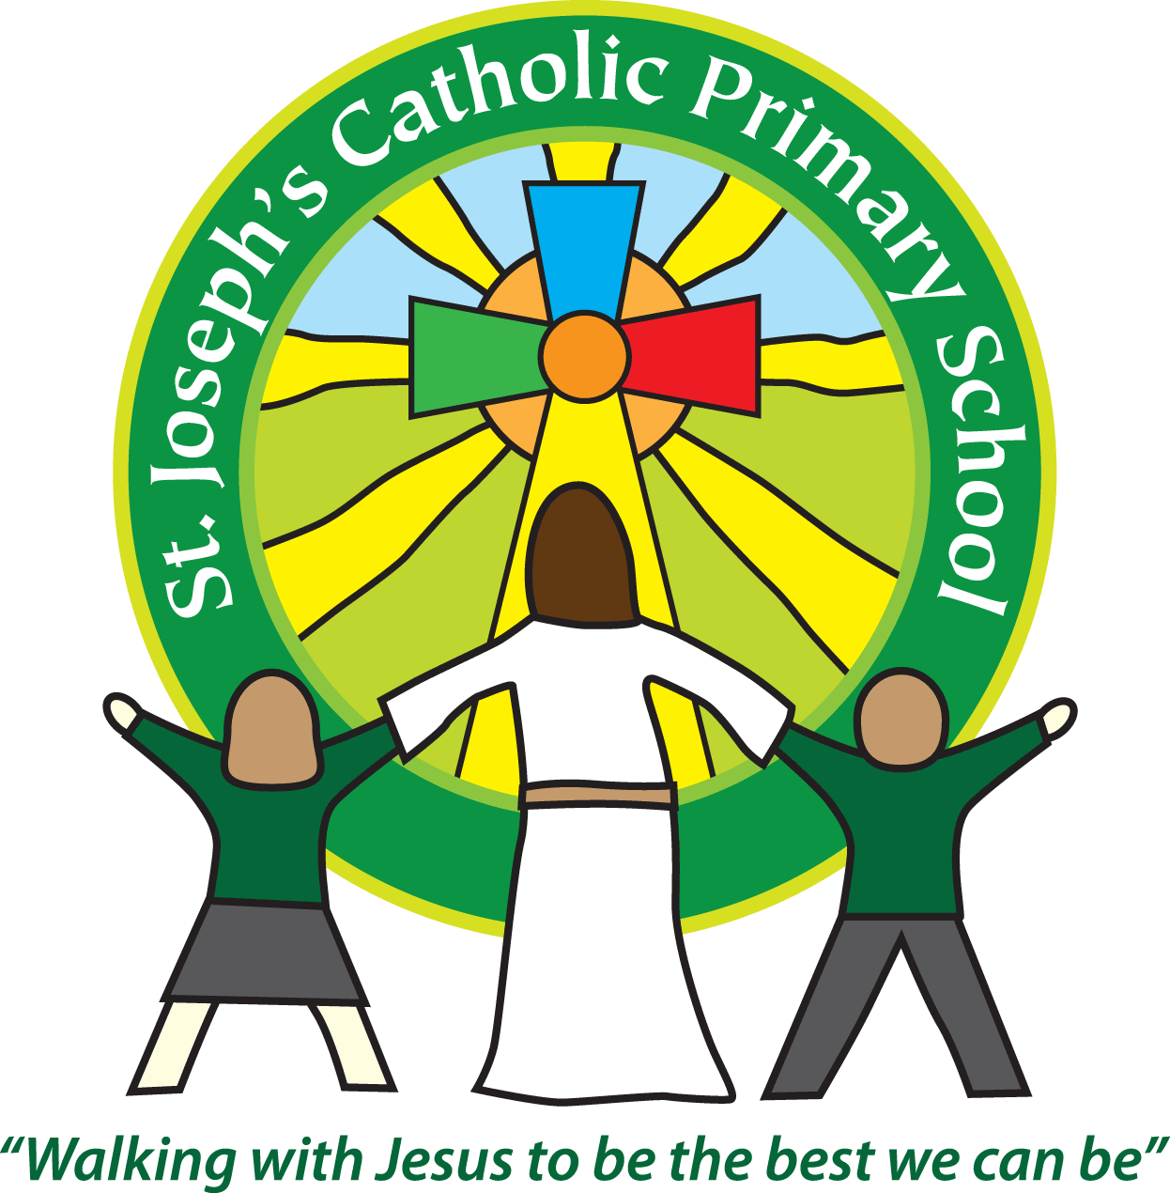

**St Joseph’s Relationships Policy**

*Kind words are short and easy to speak but their echoes are endless - Mother Theresa.*

At St Joseph’s, we know that developing and sustaining positive relationships is central to the success of our schools. We believe that trusting, honest and caring relationships must exist between all members of the school community and most importantly between adults and children. Relationships must be authentic.

Everyone at St Joseph’s understands that they have a responsibility to support the growth of positive relationships, that constant maintenance is required to maintain them and that there will be times when relationships rupture but that we all have a duty to help repair these.

St Joseph’s relationship policy provides the foundations for the behaviour policy. Adults all know that behaviour is understood as communication and that poor behaviour is as a result of an unmet need. All staff have been trained in ways to be in relationship with children, and each other, that helps everyone work together in a positive and productive way to support the emotional needs of our children and nurture positive behaviour.

Our approach to relationships is based on the teachings of Trauma Informed Schools UK (TISUK). It is underpinned by educational practices which ‘Protect, Relate, Regulate and Reflect’.

**Protect**

Our priority is to ensure that children are safe. In this context that means not only physical safety but also within the relational environment. We reduce the stress for the child by creating a warm and calm environment that is consistent, accepting and optimises social engagement. We do not place children in situations that they cannot manage and focus on creating both physical and psychological safety.

Specifically;

* All adults are taught about the impact of toxic stress on learning, wellbeing and behaviour.
* Regular whole school training to ensure that all adults have a comprehensive understanding of PACE (Playfulness, Acceptance, Curiosity, Empathy (Hughes 2016), whole school awareness of Social Engagement Theory (Porges 2017) and Panksepp’s Emotional Systems (2012).
* Ensuring that there are emotionally available adults in school and that children know who they are and where to find them.
* There is a no shouting, no shaming policy in school. Raised or hostile voices are not tolerated and any conversations with individuals about behaviour take place in private, away from the gaze of other children.
* Adults are aware of facial mobilisation and are expected to present as open, warm and engaged at all times.
* Adults are consistent and adjust their expectations around vulnerable children to meet their needs. They ensure that their interactions are socially engaging and not socially defensive.
* Adult only spaces and time to reflect is encouraged.

**Relate**

At St Joseph’s, our understanding of Relate is underpinned by the knowledge that the ability to form meaningful relationships is fundamental to mental health and happiness. We understand that relationships are crucial in promoting the optimal development of the frontal lobes of the brain associated with the executive functions key to emotional regulation, emotional intelligence, planning, problem solving and ultimately learning. There will be children in our schools who, for many reasons, have not benefitted from these positive relational experiences. Research indicates that the brain retains plasticity and repeated, positive , relational experiences can repair and reverse this cycle.

Specifically;

* All adults are attachment aware.
* All adults interact with each other, with children and with parents and carers from a position of social engagement not social defence.
* All adults know about the key relational skills (Affect Attunement, Empathy, Containment and Calming and Soothing) and use these when supporting all children.
* Adults ensure that children have daily positive relational experiences to help them to become trusting, help-seeking individuals. PACE is embedded in all interactions
* Children and adults are helped to express their emotions and are not shamed or undermined when acknowledging their anxieties.
* Adults have daily opportunities to engage with each other in environments that are supportive and pleasant.

**Regulate**

We know that leaving children (and adults) in a state of toxic stress can result in physical ill health as well as making it impossible to engage productively in the activities taking place around them. We have a duty to support children and adults in school to ensure that they are not left in toxic stress. We know that one of the most powerful ways to do this is to talk to children and help them to talk about what is bothering them. At St Joseph’s, we are committed to doing this through the relationships we have with children and each other.

Specifically;

* Providing children with time-in with an adult who they trust to help them calm down, ready to reflect
* Teaching children strategies to support them in self-regulation
* Ensuring that interactions are emotionally regulating, playful and enriched
* Ensuring that we do not engage in socially defensive behaviour with children, especially when correcting behaviour
* Our schools provide and value staff-only spaces, designed to promote regulation and reflection
* Adults are aware of each other’s needs and support each other through rich, trusting relational experiences.

**Reflect**

At St Joseph’s, we believe that children and adults need to be able to reflect on their feelings in order to fully understand them and their behaviour. Without the opportunity to do this we are far more likely to act out our feelings. Reflection enables us to make sense of our life, develop language for emotions and have a coherent narrative that makes sense of what we are feeling and what has happened to us. There are times following troubling incidents that children and adults need to be helped to reflect in order to make sense of them and if necessary, to repair ruptures in relationships that may have resulted. Such reflection takes place only once the child is calm and regulated, with a trusted and emotionally available adult who is able to offer non- judgemental support. We recognise this as being ‘connection before correction’ (Dan Hughes 2017).

Specifically:

* Staff are trained in the art of good listening with a particular focus on empathy and acceptance of the feeling if not the behaviour.
* Children have opportunities to work with trusted adults to make sense of painful experiences through creative, therapeutic approaches.
* Behaviour is understood to be a form of communication and adults respond to poor behaviour by asking not what did you do but what has happened to you?
* Restorative conversations take place when children are ready and able to think about what has happened and are supported to repair.
* PSHE is informed by current research and teaches children about mental health, emotions, relationships and how to live life well.

**Roles and Responsibilities**

Every adult that works within St Joseph’s, whether employed or voluntary is required to conduct themselves in keeping with this policy. It is the responsibility of all adults in the school to model the behaviours described and ensure that they are supporting the promotion of positive behaviour. New staff, visitors and volunteers will be expected to read the policy and training will be given to enable them to understand the principles upon which the practice is based.

Reviewed : November 2023