St Joseph’s Catholic Primary School Home Learning Pack – 18.05.2020
Willow Class

Please find the suggested timetable. This is just a suggestion and you need to find what works for you and your child as we understand that everyone learns differently. Just to be clear, we are not expecting everyone to do all of the activities and these are only suggestions. We understand that our circumstances are all very different at the moment and that lots of you will be trying to juggle ‘home school’ and your own work as well as caring for elderly neighbours and family. Please only do what you feel you can. We do not want to set anything that causes any worry so please do what you feel. There are some references to resources but they do not need to be printed and can be viewed online and the work can be completed or copied onto paper. Please contact us at admin@stjo.uk and in the subject name it… For (Your Child’s teachers name and Class) if you need any further support. For example; For Mrs Spinks, Willow Class. This will help us to ensure your request is dealt with quickly.
Suggested Family Home Learning Timetable
This is a guide to help you establish a routine for your children – this is just a suggestion and you will need to adapt it to the needs of your family.
Time | Activity
Before 9.00 | Get up, washed, dressed, make beds and eat breakfast
9.00 – 9.30 | PE with Joe or family walk
9.30 – 9.45 | Drink and get ready for home learning
9.45 – 10.30 | English – writing, spelling or grammar activity from your home learning pack
10.30 – 11.00 | Break time - take a snack and drink outside if you can
11.00 – 11.45 | Maths – choose an activity from your home learning pack
11.45 – 12.30 | Creative time – draw, paint, sew, bake, do a job in the garden, stop-motion animation with lego / plasticine (the list is endless). Have a project that you can do a bit of everyday.
12.30 – 1.15 | Lunch – help to make it AND clear up after it!
1.15 – 1.30 | Chores – do a job around the house e.g. put laundry away, tidy your room, vacuum or polish
1.30 – 2.00 | Quiet time – shared or independent reading
2.00 – 3.00 | Topic time – science / art / history / geography / music – choose a topic activity from the home learning pack

All of the resources for the home learning below can be found at: https://www.stjosephsprimaryschool.com/website/home_learning_04052020/477542 on the Coronavirus information page – Home learning and then select the date and appropriate class.
Maths | Activities | Resources
Times tables | Please continue to practise your times tables everyday this can be done on TTRS or offline through a variety of games and activities. Here are a few ideas to help you:  - Use playing cards – Choose 2 cards at a time and multiply the numbers together and then discuss corresponding division facts.  - Exercise while reciting your times table facts e.g. skipping  - Play times table ping pong – in partners take it in turns to ask each other questions  - Times table bingo – draw a 3x3 grid and choose numbers from the tables – bingo caller to ask multiplication and division question.  - Why not invent your own times table game to play?
Day 1 | Can I multiply numbers using the grid method?  - Go through the power point or read the learning reminders to refresh your understanding.  - Complete the practice questions  - If you are finding it tricky complete the ‘A bit stuck sheet’.  - Answer the questions to check your understanding. | PDF document ‘Maths day 1’ on the website.  Power point Maths day 1
Day 2 | Can I multiply numbers using the grid method?  - Read the learning reminders to refresh your understanding.  - Complete the practice questions  - If you are finding it tricky complete the ‘A bit stuck sheet’  - Have a go at the investigation to check understanding | PDF document ‘Maths day 2’ on the website.
Day 3 | Can I identify different angles in triangles?  - Read the learning reminders to refresh your understanding.  - Complete the practice questions  - If you are finding it tricky complete the ‘A bit stuck sheet’.  - Complete the questions to check your understanding | PDF document ‘Maths day 3’ on the website.
Day 4 | Can I identify different angles in quadrilaterals?  - Read the learning reminders to refresh your understanding.  - Complete the practice questions  - If you are finding it tricky complete the ‘A bit stuck sheet’.  - Have a go at the investigation to check understanding. | PDF document ‘Maths day 4’ on the website.
Day 5 | Can I sort quadrilaterals?  - Read the learning reminders to refresh your understanding.  - Complete the practice questions  - If you are finding it tricky complete the ‘A bit stuck sheet’.  - Complete the questions to check your understanding. | PDF document ‘Maths day 5’ on the website.

Please continue to keep a written diary recording what you have done each day.
English | Activities | Resources
Day 1 | Can I use and identify determiners in my writing?  - Read Hero Dad.  - Look through the power point or learning reminders to refresh your understanding of determiners.  - Complete the worksheet ‘Determiners: Identify, Choose, Use’.  - Write about an imaginary adventure. | PDF document ‘English day 1’ on the website.  Determiner power point on the website.
Day 2 | Can I write a poem using determiners?  - Re-read Hero Dad.  - Use the Revision Card to remind yourself about determiners.  - Find and highlight the determiners in the poem, ‘Hero Dad’.  - Use the poem frame to write your own poem about someone in your family or a friend of yours. Explain why they are a hero to you. | PDF document ‘English day 2’ on the website.
Day 3 | Can I express my opinion and explain my thinking?  - Watch this this video from 1:03 to 5:45 https://www.youtube.com/watch?v=0L-TpcdwI9Q  - Think about the stories message.  - Read these four stories from Africa: The Lion’s Share, Two Roads Overcame the Hyena, The Two Cold Porcupines &The Community of Rats.  - Answer the story questions.  - Write a single sentence summary for each story. | PDF document ‘English day 3’ on the website.
Day 4 | Can I retell a story?  - Read these three stories from Africa: Creation and Separation Myth of Man and the Elephant, How the Monkeys Saved the Fish & The Poor Man without work. How are they similar to the stories that you read yesterday?  - Watch The ‘Yes, Sir’ Chief again (1:03 to 5:45) https://www.youtube.com/watch?v=0L-TpcdwI9Q  - Make a list of what the story teller does to make the story interesting.  - Pick your favourite story from today or yesterday and make a story board of your chosen story.  - Practise telling your story. | PDF document ‘English day 4’ on the website.
Day 5 | Can I write a story using fronted adverbials and conjunctions?  - Read Two Stories.  - Look at the revision cards to remind yourself about conjunctions and fronted adverbials.  - Complete the worksheet.  - Write your own version of an African story. | PDF document ‘English day 5’ on the website.

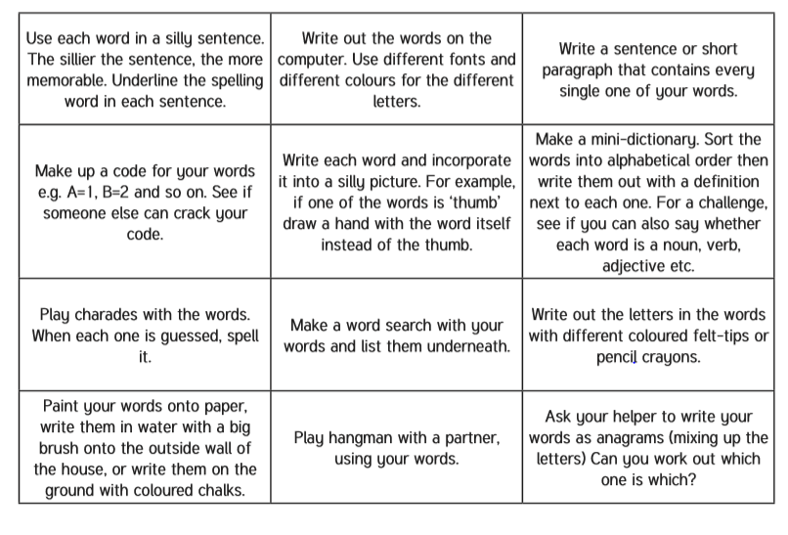
Spelling – Practise the year 4 spellings using a range of strategies. Below are some ideas that you can try.

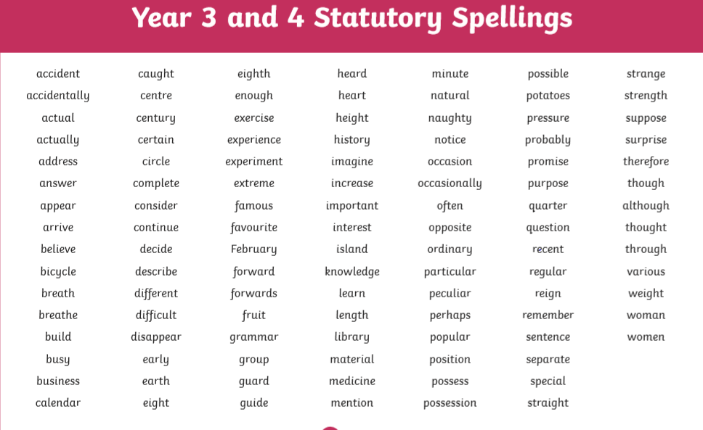
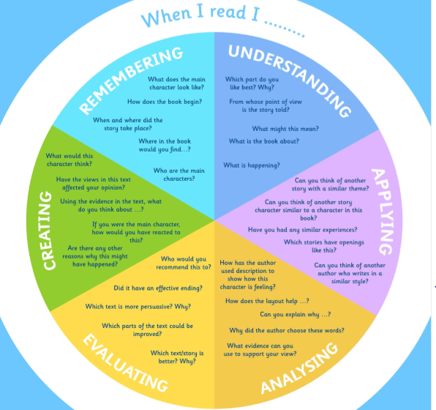
Suggested Reading Activities
This is an essential skill that the children need to continue to practise daily. It is recommended that the children read for at least 20 minutes each day. Continue to record all reading in the reading record books and remember to quiz on accelerated reader. You should have received an email with log in details. Please contact me if there is an issue with this. When listening to your chid read ask questions regularly to check and support understanding. Here is some example questions which would really support the children in their development.

Varied activities of Science, Music, Topic (History, Geography, Art) and R.E
 | Activities | Resources
Activity 1 | Can I retell the story of Pentecost?  Read the story of Pentecost and watch the clip: https://www.youtube.com/watch?v=MtTjgmlUtps  Retell the story of Pentecost. Let’s get creative! You can choose how you retell the story. You could create a video similar to the clip or you could create a story board with pictures and captions. | RE document on the website.  https://www.youtube.com/watch?v=MtTjgmlUtps
Activity 2 | Can I create a poster to help people to care for ‘Our Common Home’?  Create a poster to help people to care for ‘Our Common Home’. What can people do to care for our world? How can we support Pope Francis’ message?
Activity 3 | Can I use my reasoning skills to decode a rhyming verse?  - Use the clues to decode the rhyming verse.  - You will need to check that it is in the right order.  - Challenge: have a go at creating your own code for somebody in your family to solve. You could use a verse from your favourite poem or song. | Computing document on the website.
Activity 4 | Can I draw my digital footprint?  A digital footprint is a trail of footprints that you leave behind every time that you go online. Most websites record your IP (Internet Protocol) address, a set of numbers which is unique to your device.  Think about the ways that you use the internet. Do you message your friends? Do you go on different websites? Do you download music?  - Draw around your foot on a piece of paper  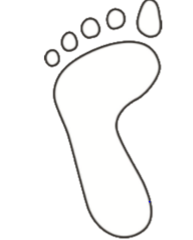  - Inside of your footprint draw or write all of the different ways that you use the internet. | Paper, pencil
Activity 5 | Can I observe how a shadow changes over time?  - Place a piece of white paper on the windowsill directly below the object. Make sure the object is in the centre of the page. A shadow should appear on your paper. Draw around the shadow and label it with the time. Check on the shadow every hour or half hour throughout the day, each time drawing and labelling the shadow.  - Use your observations to make a sundial. What distance is there between each hour? Is each hour the same distance apart? Would the clock be correct all year around? Would your clock work if it were used in a different country eg. Australia, South Africa, Algeria? | Science task 4 on the website.

