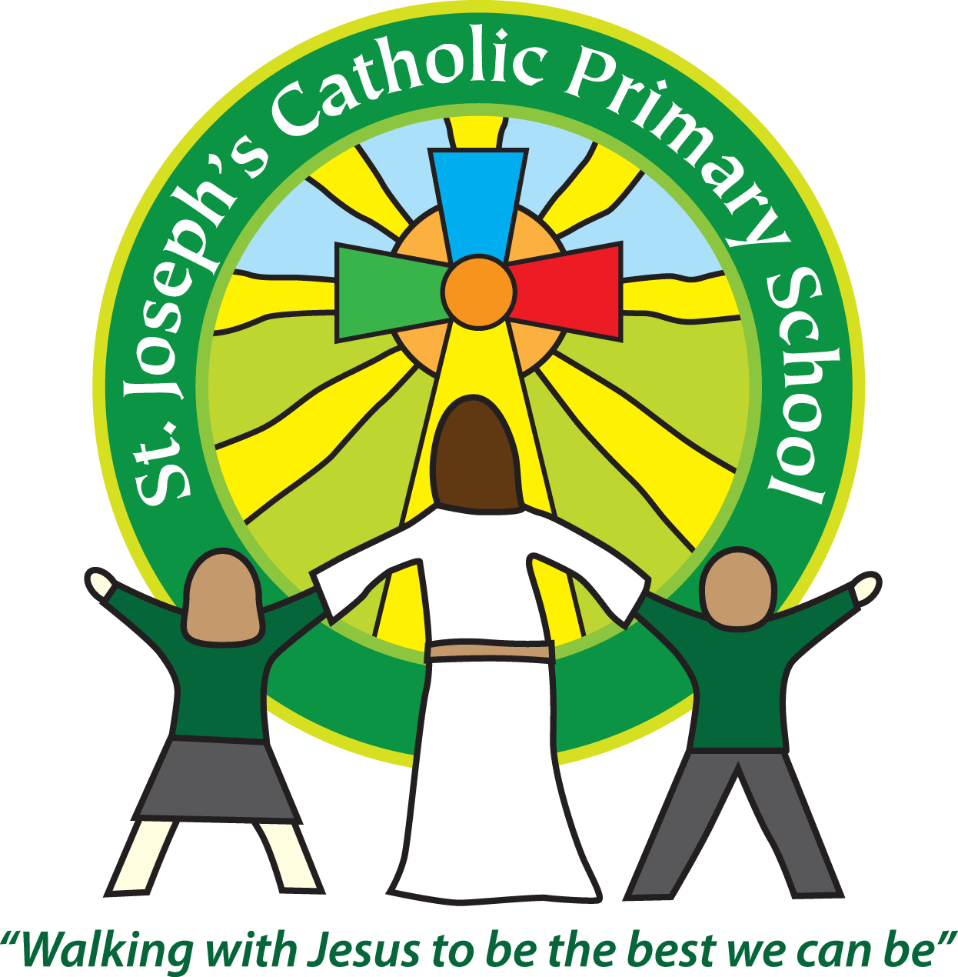
ST Joseph’s CATHOLIC PRIMARY SCHOOL

VOLUNTEER IN SCHOOL WRITTEN REQUEST FORM

Name

Child(ren)’s name(s) and current class
Address

Telephone No

Email

In what capacity are you able to support teaching and learning?  (Please circle) | Reading Writing Maths ICT Science PE Cooking  RE History Art Geography Design Technology Sewing/craft  Library Swimming Lunchtime club After School club Other
How many hours a week are you regularly able to support teaching and learning?  (Please circle) | 0 1 2 3 4 5 more
Days available  (Please tick) | Mon am | Mon  pm | Tues  am | Tues  pm | Wed  am | Wed  pm | Thurs  am | Thurs  pm | Fri  am | Fri  pm

I have read the Volunteer’s handbook and Safeguarding policy.
I understand this role requires a DBS check.

Signed ……………………………………………….. Date …………………………

FOR OFFICE USE ONLY

Safeguarding Policy issued ………………………………………………………………………………..

Volunteer Handbook issued ………………………………………………………………………………..

Assigned to class ……………………………………………………………………………………………..

DBS online log in forwarded……………………………………………………………………..…………..

DBS check certificate number registered………………………………………………..………………….

