Mathematical understanding:

Numbers to 50

We will explore numbers to 50, including their place value and relative sizes, extending their calculation skills and number knowledge to larger numbers and to an increasing range of situations. Children will also be introduced to counting in multiples of 2 and 5, and will be encouraged to notice that multiples of 2 end in 0, 2, 4, 6 or 8 and that multiples of 5 end in 0 or 5.  
Measure

This unit focuses on comparing and measuring the height and length of objects using non-standard and standard units of measure. We will then follow this up with a unit looking at weight and volume.

Computing

This unit introduces pupils to data and information. Pupils will demonstrate that they can count a small number of objects, before and after the objects are grouped. They will then begin to demonstrate their ability to sort objects into different groups, based on the properties they choose. Finally, pupils will use their ability to sort objects into different groups to answer questions about data.

Understanding English, communication and languages

Non Fiction – The children will further explore non-fiction writing and work towards creating their own Recount.

Narrative – The children will share the story ‘A Way back Home’ by Oliver Jeffers as they build on skills to create their own story.

**Transport**

**In the Past**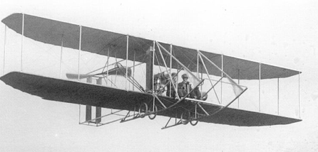

**Rowan Class**

**Spring 2**

Understanding physical development, health and wellbeing:

**RSE:** Created to Love Others, explores the individual’s relationship with others. Building on the understanding that we have been created out of love and for love, this module explores how we take this calling into our family, friendships and relationships, and teaches strategies for developing healthy relationships and keeping safe.

P.E. every Tuesday and Thursday

Understanding the arts:

**Art**

We will learn about making a 3D paper structure, by exploring the work of artists such as Samantha Stephenson.

**Music**

• Play tuned & untuned instruments musically.

• Compose simple performance pieces.

History - Transport in the past

Children will learn that transport has changed significantly within living memory. They will explore travel by land, sky and sea and focus on the impact made by individuals including Henry Ford, George and Robert Stephenson, Amelia Earhart, Karl Benz and The Wright Brothers.

RE:

**Relating**

Know and understand:

• Families and groups share special meals **– Explore**

• Mass as Jesus’ special meal **– Reveal**

**Giving**

Know and understand:

• That we change and grow – **Explore**

• Lent; a time to change in preparation for the celebration of Easter – **Reveal**

Science – Investigating Materials

Following on from our unit on materials, we will focus on investigating materials by testing objects made of different materials to see how effective they are in a particular application. Children will offer ways of gathering evidence to answer a question and conduct simple tests.