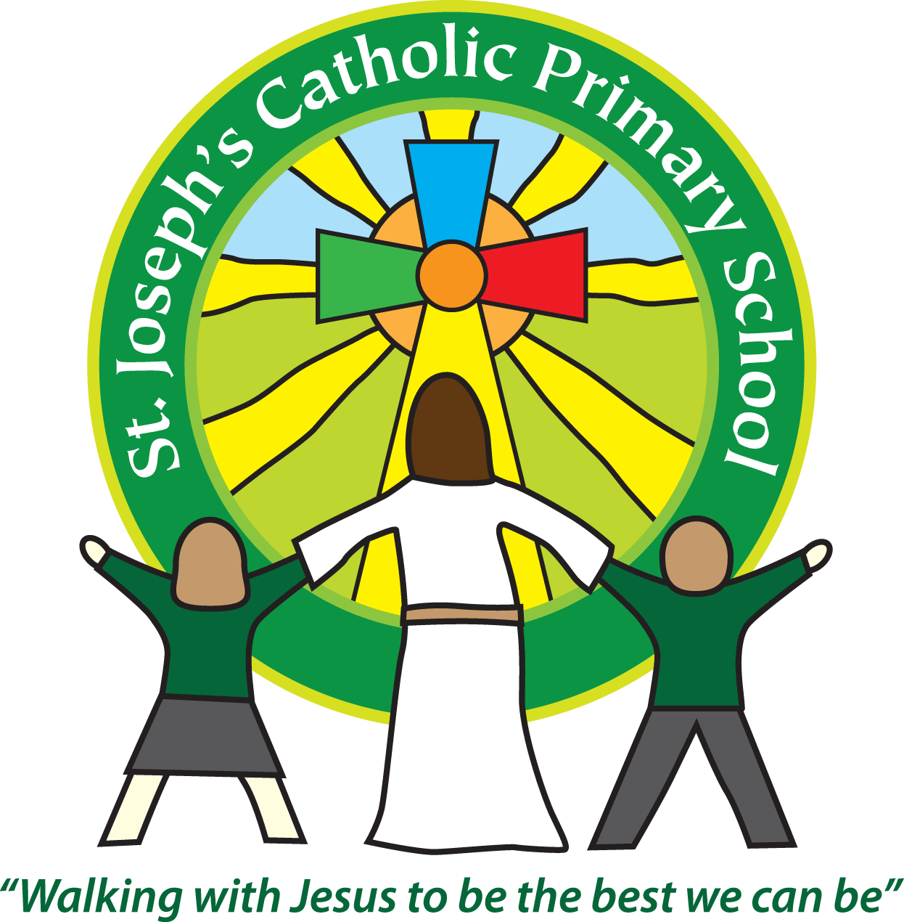
St Joseph’s Catholic Primary School Home Learning Pack
Class: Maple
Please find the suggested timetable. This is just a suggestion and you need to find what works for you and your child as we understand that everyone learns differently. Just to be clear – we are not expecting everyone to do all of the activities. We understand that our circumstances are all very different at the moment and that lots of you will be trying to juggle ‘home school’ and your own work as well as caring for elderly neighbours and family. There’s very little that needs to be printed out – lots of the resources can be viewed online and the work completed on plain paper. Please contact us at admin@stjo.uk and in the subject name it… For (Your Child’s teachers name and Class) if you need any further support. For example; For Mrs Jukes, Maple Class. This will help us to ensure your request is dealt with quickly.
Suggested Family Home Learning Timetable
This is a guide to help you establish a routine for your children – this is just a suggestion and you will need to adapt it to the needs of your family.
Time | Activity
Before 9.00 | Get up, washed, dressed, make beds and eat breakfast
9.00 – 9.30 | PE with Joe or family walk
9.30 – 9.45 | Drink and get ready for home learning
9.45 – 10.30 | English – writing, spelling or grammar activity from your home learning pack
10.30 – 11.00 | Break time - take a snack and drink outside if you can
11.00 – 11.45 | Maths – choose an activity from your home learning pack
11.45 – 12.30 | Creative time – draw, paint, sew, bake, do a job in the garden, stop-motion animation with lego / plasticine (the list is endless). Have a project that you can do a bit of everyday.
12.30 – 1.15 | Lunch – help to make it AND clear up behind it!
1.15 – 1.30 | Chores – do a job around the house e.g. put laundry away, tidy your room, vacuum or polish
1.30 – 2.00 | Quiet time – shared or independent reading
2.00 – 3.00 | Topic time – science / art / history / geography / music – choose a topic activity from the home learning pack
3.00 – 3.15 | Break time – take a snack and drink outside if you can
3.15 – 4.00 | Physical Activity – PE with Joe, family walk, yoga, Just Dance (look at Mrs Turner’s suggestions)

Hello everyone – I hope you are all well and finding a routine that works for everyone in the household. I know it’s not easy with everyone trying to share the same space (and internet!) so I have tried to give a variety of activities so you have a choice – you are not expected to do everything! I didn’t hear from any of you last week, so I assume that means you all got on okay?! Please do email if there is anything I can do to support you while we are away from school. I think of you all regularly and wonder what you are all up to! Take care of yourselves and your family!
Mrs Jukes
Maths |  | Activities | Resources
Day 1 | Can I divide by 10, 100 and 1000? | Fluent in five (just to get you warmed up):  - 8 x 7  - 40 x 7  - 6764 + 1643  - 1.2 x 100  - $\frac{1}{3}$ of 42  Today we are revising using place value to divide by 10, 100, 1000 so you might want to draw yourself a place value chart with 7 columns (thousands -> thousandths). See Maths_Wk2_Day1.doc for examples and questions. In these help sheets, I’ve used squared paper so that you can see how we would lay it out in school – but don’t worry if you don’t have squared paper at home! | Maths_Wk2_Day1.doc  Choose Marvellous / Magnificent / Mind-blowing as we would in class.
Day 2 | Can I use the bus stop method for short division? | Fluent in five:  - 186 + 70  - 5667 + 3334  - 67 x 7  - 3462 – 746  - $\frac{1}{4}$ of 36  Today we are going to be looking at the bus stop method for short division (this is called a formal written method). You will have come across this method in year 4 but might need a reminder! Examples and questions are in the document attached. | Maths_Wk2_Day2.doc
Day 3 | Can I find remainders in division problems? | Fluent in five:  - 3 x 7  - 161 ÷ 7  - 377 + 40  - 7643 + 1339  - 26 x 7  There are 3 ways to find a remainder. Which one we choose, depends on the question we are answering. Today we are going to learn how to find a remainder as a whole number remainder and as a fraction. Tomorrow, we will look at finding a decimal remainder. | Maths_Wk2_Day3.doc
Day 4 | Can I find remainders in division problems? | Fluent in five:  - 70 x 6  - 237.3 – 14.46 (line up decimal point and use a place holder zero!)  - 37 x 6  - 674 + 70  - $\frac{1}{5}$ of 25  Today we are going to be finding remainders as decimals. This way of finding remainders is necessary for answering questions about money e.g. if you are splitting a bill between friends. | Maths_Wk2_Day4.doc
Day 5 | Can I solve problems involving division and give remainders appropriately? | Fluent in five:  - 91 ÷ 7  - $\frac{1}{3}$ of 27  - 217 ÷ 7  - 3327 + 4375  - 900 x 7  I have written some word problems for you to answer today – you will need to decide how to give the remainder. | Maths_Wk2_Day5.doc

English |  | Activities | Resources
Day 1 | Can I identify expanded noun phrases? | We have looked at noun phrases in class – so this should be revision for you! Read the instructions on the first page and then read the poems. You are going to be identifying the noun phrases in the second poem. There are some thought provoking questions about the first one that you could do as a warm up! You will use the poem, ‘Golden Time’ as a structure for your own poem later this week – so definitely read it! | English_Wk2_Day1
Day 2 | Can I perform a poem? | Perform a poem! Look at the same PDF link that you used yesterday. Read ‘Preparing to Perform’ and follow the link to the BBC website where there’s a clip about poetry performance (this isn’t essential if you can’t get online). Choose either poem and have a go at learning it for a recital – you might be able to learn the whole thing, or just a verse or two. Perform it to someone at home – maybe you could teach it to them and you could perform it together! | English_Wk2_Day1
Day 3 | Can I use expanded noun phrases to create my own poem? | Today you are going to be a poet! All the instructions are in the PDF attached (see resources) but you don’t need to print it out – you can write your poem on a piece of paper and design your own border to decorate it! If you can take a photo and send it to school, I’d love to read your poems! | English_Wk2_Day3
Day 4 | Can I use commas to separate phrases and clauses? | Today’s reading is a newspaper article written about a school that made some unpopular changes to their uniform. Read it and then identify the Who, Where, When, What and Why? (You don’t need to print out the table – you can make your own). Then use the comma revision cards to help you complete the work, ‘For and Against School Uniform 1’ and ‘For and Against School Uniform 2’. By the way – I disagree with their use of phrases and clauses. On the sheet, the clauses have been highlighted yellow – I would call these independent or main clauses (the parts of the sentence that make sense by themselves). The parts highlighted green, they have called phrases – this is the bit I disagree with! I would call these the dependent or subordinate clause or phrase. Remember that the difference between a phrase and a clause is that a clause contains a verb and a phrase does not. So, ‘In the real world’ is a phrase because it does not contain a verb BUT ‘because they restrict choices’ is a clause because it contains the verb, restrict. See my problem?? Anyway – this won’t stop you being able to do the work!! The answers are at the end of the document. The writing bit at the end comes tomorrow … | English_Wk2_Day4
Day 5 | Can I write a balanced argument? | Using the same document as yesterday and the work you did then, you are going to write 2 paragraphs: one to argue FOR school uniform and one to argue AGAINST it. All the instructions are in the writing brief (including a success criteria). | English_Wk2_Day4

Suggested Reading Activities
Please, can I encourage you to keep reading (and quizzing if possible) as this is the very BEST thing you can do to support your progress in learning. Read fiction (story) books, newspapers, magazines, comics, non-fiction texts (about real stuff) – anything will help. Got an encyclopaedia at home? Learn a new fact about the world everyday – create a notebook and fill it with interesting facts, adding detail by drawing pictures or researching more about it online. Your brain will soon be the size of Britain!!
You should all be aiming for AT LEAST 20 minutes of reading a day! Mrs Taylor-Bashford has sent links to websites to support you reading at home.
Well done to those of you who have quizzed on AR since 20th March but I can see that lots of you haven’t. Please let me know via email to admin@stjo.uk if you need help getting on to AR from home and I’ll see what I can do!
Spelling
Year 3/4
eighth
enough
exercise
experience
experiment
extreme

Year 5/6
disastrous
embarrass
environment
equip
equipped
equipment

Use a dictionary (online is fine) to find out what these words mean, use them in a sentence and use the cover, write, check method to learn how to spell them. Get someone at home to test you like we do in class.

Varied activities of Science, Music, Topic (History, Geography, Art) and R.E
 |  | Activities | Resources
Day 1 | Can I investigate water resistance? | Find two lumps of plasticine, playdoh or blu-tac. They must weigh the same, so get the kitchen scales out! Roll one into a ball and time how long it takes to get to the bottom of a bucket of water. It would be helpful if you have a transparent container to do this in – a large storage container or even a fish tank would be great (so long as there are no fish still in it!!). Now, take the other lump and change its shape so that it falls slower through the water than the ball. Which shape falls the slowest? Can you get a shape to float?  Think about our falling paper experiments when we learned how air resistance is a force that is pushing up against the pull of gravity as the paper falls. There is more air resistance acting on a flat piece of paper than on a screwed up ball of paper because there’s more surface area. Can you use this understanding to help you explain what is happening to the shapes of play-doh? Write up your test. Can you include:  - investigation question (aim)  - method (step by step what you did)  - results (how could you present your results?  - conclusion (what did you find out? can you explain why?)  Now – can you design a shape that falls faster than the ball of playdoh? For more help, follow this link:  https://www.bbc.co.uk/teach/class-clips-video/science-design-and-technology-ks2-investigating-air-and-water-resistance/z4m6nrd | - Lumps of plasticine, play-doh or blutac.  - A large container to hold water (a transparent one would be great)  - Timer
Day 2 | Can I find out about how Muslims celebrate Ramadan? | Ramadan is an important time in the Muslim calendar. This year it begins on 23rd April (Thursday). Follow the links to find out more:  https://www.bbc.co.uk/bitesize/topics/zpdtsbk/articles/zjc2bdm  “Almost all Muslims will try to give up bad habits during Ramadan. It is a time for prayer and good deeds. They will try to spend time with family and friends and help people in need.”  There is plenty of opportunity for us to be helping people in need too – how about making a card to send to a local care home or one of your neighbours who might be feeling a little lonely? Or maybe you could help a younger sibling to get their school work done, or just spend some time playing with them! If you haven’t got a rainbow in your window to make people smile – that would be a lovely thing to do too!  How about a Ramadan recipe? https://www.bbcgoodfood.com/recipes/collection/ramadan
Day 3 | Can I do something to celebrate Earth Day? | Today (just before dawn!!!) will be the best time to see the annual Lyrid meteor shower. So, if you’re an early riser – get outside and look up – you might just see a meteor moving across the sky!  It is also the 50th anniversary of Earth Day which has been celebrated every year on 22nd April since 22.4.1970! Find out more here: https://www.earthday.org/earth-day-2020/  One good thing about countries around the world being in lockdown is the reduction in pollution which leads to climate change. Do something today to celebrate Earth Day. Some ideas:  - Design a poster about climate change – what causes it? How can we stop it?  - Create a wildlife haven in your garden – can you plant some wild flowers or make a bug hotel?  - Produce a piece of artwork that shows off our wonderful planet – you could collect natural things and create a collage or draw your favourite place to explore. You might even be inspired by the meteors to create a piece of night-sky art!  - Turn off lights when you leave the room and don’t leave your electronic devices on standby when you’re not using them! Turn the tap off when you are brushing your teeth to conserve water … what else?  I’m sure you could come up with lots of imaginative ways to celebrate Earth Day!
Day 4 and 5 | Can I write an information text about a volcano situated on the ring of fire? | Read the information about plate boundaries and the Ring of Fire attached. If you want to know more, I will upload another information pack for you to explore.  There are at least 452 volcanoes along the Ring of Fire – your task is to find out about one of them. Some famous ones include: Mount Fuji (Japan), Mount St Helen’s (America) and Popocatepetl (Mexico). How are the lives of people living near to the volcano affected? What are the advantages and disadvantages? Why do people continue to live so close to a volcano? Write a short information text about your chosen volcano. Remember to set it out like a non-fiction text with headings, sub-headings, diagrams and pictures (with captions).  If research is difficult because you can’t get online, how about having a go at another volcano experiment? Take a photo or draw a diagram (and label it) of your experiment and write about what you observed happen and explain what this shows us about what happens in a real volcano. The notes with each experiment will help you but don’t just copy – make sure you explain in your own words – this will help you learn! | Topic_Wk2_Day4and5  Plate_Tectonics_  Information_Text PDF

