Can I convert between units of time?
Units of Time
60 seconds = 1 minute  60 minutes = 1 hour  24 hours = 1 day | 7 days = 1 week  12 months = 1 year  365 days = 1 year

Conversion diagrams:
÷ 60

÷ 60
secs mins mins hours
x 60
x 60

Step 1
Write out the measurements you need, thinking about how many of one are in the other. For example, if you are converting seconds to minutes, you need to know that there are 60 seconds in a minute. Use the appropriate conversion diagram to help you.
What is 240 seconds in minutes?
240 ÷ 60 = 4 minutes

÷ 60
secs mins

x 60

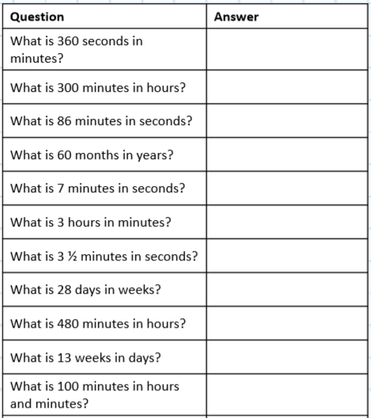
Your turn

