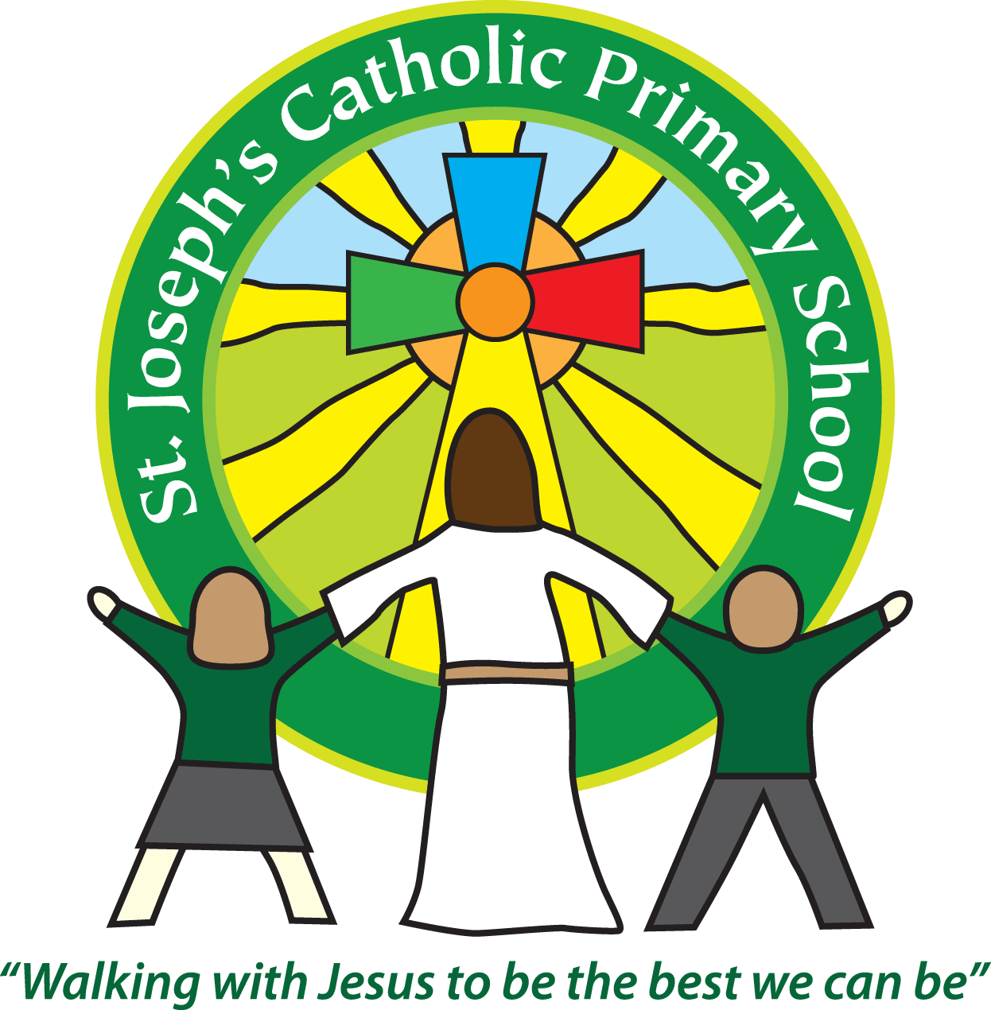St Joseph’s Catholic Primary School
Year 3 and 4 – Cedar class
Mrs Owens and Mrs Monks
Autumn term 1
Welcome back to Cedar Class! I am very pleased to see you all.
This half term our topic is - Marvellous Minds
Homework
Subject | Sent home | Due in | Frequency
Spellings -  to be tested in dictation on a Friday | Friday | Thursday | Weekly
Times Tables  Times Table Rock Stars  Year 3 tables are  3x, 4x & 8x tables and related division facts.  Year 4 need to have all there tables and related this year | Friday | Thursday | Weekly
Maths/Grammar | Friday | Thursday | Alternate Fortnightly
Topic | Friday | Thursday | Alternate Fortnightly
Reading | We expect the children to read at home daily. Please make sure that you regularly read with your child and discuss the books that they are reading. Please note: it is important to question your child about what they have read e.g. How do you think Tess felt when she left the house? Why? These open questions require children to use evidence from the text to support their judgements. It would also be useful if you could ask your child to collect new/unknown words from their reading record book, find their meaning and share them with the class.

Reminders
School lunch and snacks | For year 3-6, school lunch can be ordered daily at a cost of £2.35. Please pay on Parent Pay.  We promote healthy eating at school and so lunch boxes should not contain more than one chocolate snack and one packet of crisps.  Children are welcome to bring fresh fruit or vegetables for a snack at break time.  We are a nut free school. We have children with potentially fatal nut allergies in school, therefore no food containing nuts may be sent into school.
Drinks | Your child must have a named water bottle in school every day. Please only send in water, no juice or fizzy are allowed. Please see the class teacher if there is a problem in this area.
Uniform | Please ensure all uniform is clearly named.  Grey trousers or shorts, grey skirt or pinafore dress, white or grey socks, grey tights, White polo shirt, Green logo school sweatshirt or cardigan. Warm weather option – green and white gingham dress (dress with shorts instead of skirt is acceptable).  Hair past shoulder length must be tied back – please use plain hairbands in green, black or white, not brightly coloured bows.  Nail varnish is not allowed. School shoes must be black and no heels, trainers or boots.
PE Kit | Green t-shirt with school logo, black shorts, navy or black jogging bottoms and trainers. All kit must be named and in a named bag.  Ear rings must be removed or covered with tape for PE lessons.  Watches must be removed for PE.  PE kit must be in school every day.
Bags/resources from home | Children must only bring in a book bag, water bottle/packed lunch and piece of fruit daily. Please avoid other bags. Forest school footwear can come in a named bag on a Thursday. PE bags can be kept in school.
Mornings | Doors open to the classroom at 8.55am – please come as close to that exact time as possible to ensure social distancing. Please do not come onto the Patio area.  Your child will be greeted at the class door by an adult. Please only pass on quick messages at that point, for a longer meeting please make an appointment at the office or briefly with the teacher.  Children and parents arriving after 9.00am must go to the office to be signed in.
After school | School finishes at 3.30pm. If someone other than yourself is collecting your child please ensure the office has their details. We will not let the children leave unless we are sure they are safe.
Contact details | Please ensure you contact details and those of other people who may collect your child are always kept up to date. Please see the office asap if you change your phone number or address.

Teaching assistants
The teaching assistants who may be working with your child this half term are Mrs Briggs and Mrs Coleman
Specialist teachers
On a Thursday afternoon, year 3 and 4 will have Forest school this term with Mrs Turner.
PE will take place on a Wednesday afternoon with Mrs Monks and the children have daily fitness sessions with Mrs Owens in the mornings.

We recognise the importance of passing information between parents and school so we are available at the start and end of the day if you need to pass on any messages. However, if you would like a longer chat please make an appointment with us.

Yours sincerely,
Samantha Owens and Mrs Monks

