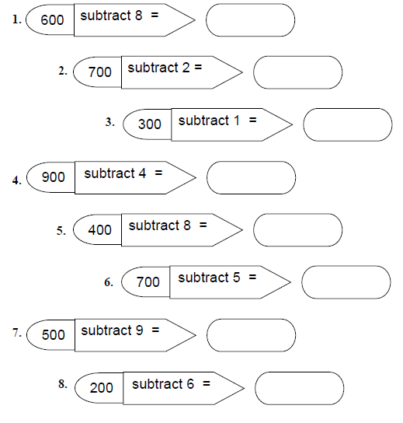
Can you use mental methods to work out these subtraction problems?

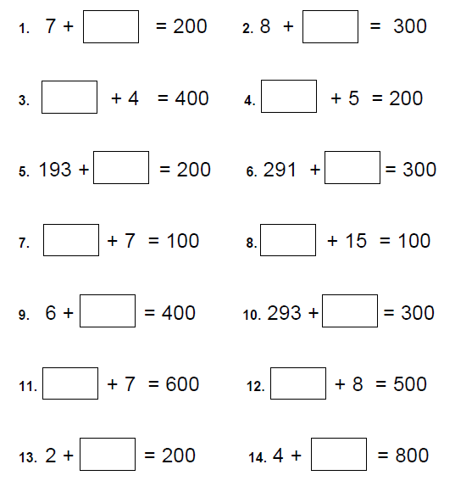

Can you use subtraction to find the missing numbers?

