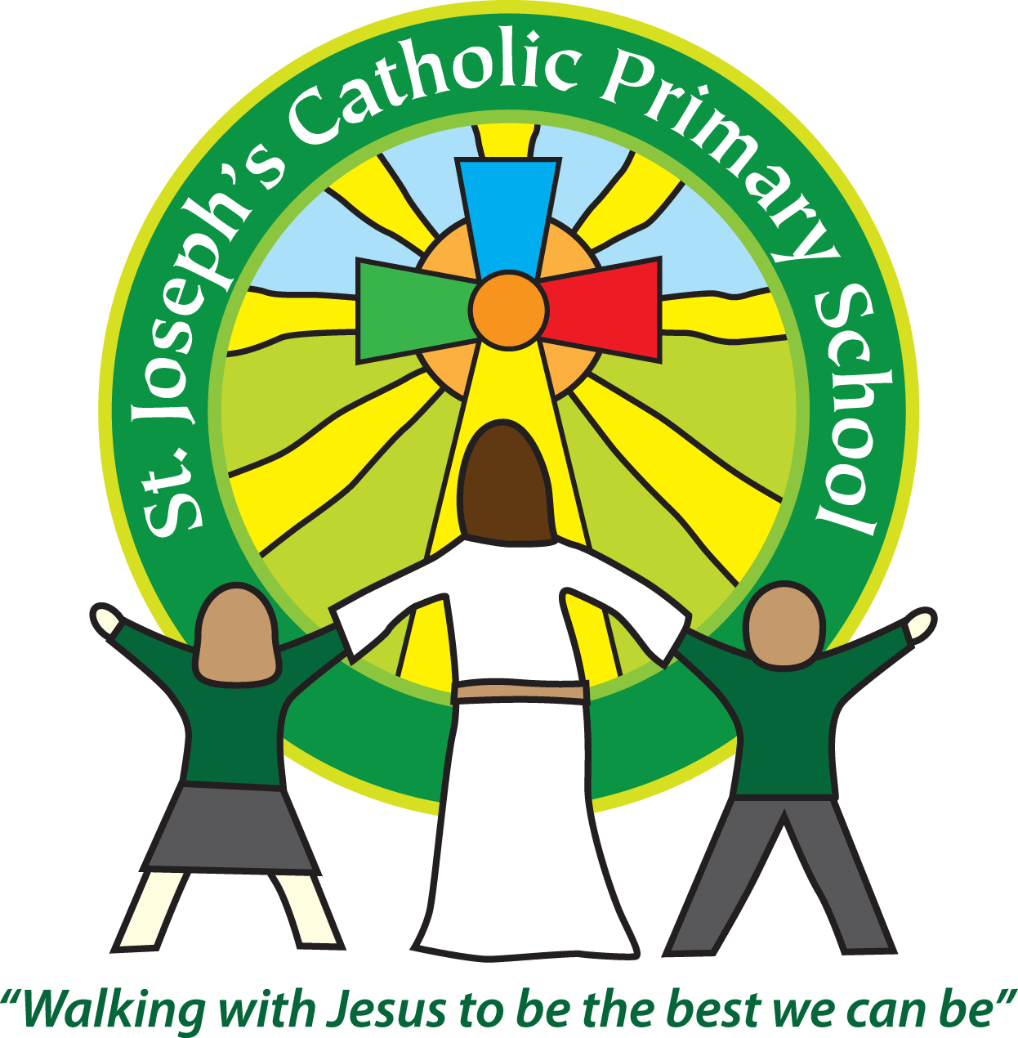
St Joseph’s Catholic Primary School Home Learning Pack
Week 3 and 4 - 15th – 26th June
Class: Cherry
Hello everyone,
It has been lovely to speak to those children I could reach last week. Hope everyone is well and happy. For these two weeks we are continuing the theme of the natural world which builds on aspects of work we did in class last term. I have added in a music programme that has an exciting conclusion - working with the Bournemouth Symphony orchestra – I hope you all get to have a look and can access the workshops, they look like fun. Also catch up with NSPCC and Buddy in the ‘Speak out and Stay Safe’ assembly; he has lots of important information for you.
Please could you also try to do the TTRS assessment (session 6 maths below) if you are able? Thank you.
I hope you are all still enjoying your reading. There is quite a lot of reading material in the topic packs this week to help you with this. Mrs Briggs and I look forward to speaking to you all soon in a short video soon.
From Mrs Owens

Home learning attachments (for those receiving this as an email)
For home learning during the partial school closure please go to the tab which says Coronavirus information – Home learning, then select the date and class.
Many thanks

Maths | Activities
Mental maths strategies:  Visualise using a bar graph.  Mental maths can include recording. | Match each fact to the bar graph it represents. Which number operations are you using?  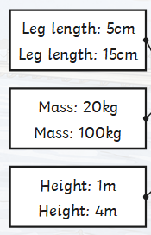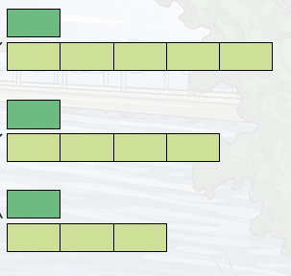  (Answers below) | Resources
Session 1 | Find a difference between pairs of numbers within the same century (‘Frog’). | See session 1 for activity
Session 2 | Use counting up (Frog) to calculate change from £5, £10 and £20. | See session 2 activities
Session 3 | Use counting up to find the difference between two amounts of money. | See session 3 for full explanation
Session 4 | Revising finding unit fractions of amounts. | See session 4 for full explanation
Session 5 | Find non-unit fractions of quantities using division and multiplication. | See session 5 for full explanation
Session 6:  Times Tables | Please make sure you have done at least 10 sessions in the STUDIO for an online assessment. Thank you  Answers to above mental maths fact 1 to model 3(3x5=15 or 15 divided by 3=5)  fact 2 to model 1 ( 20x5=100 or 100 divided by 5 = 20) and fact 3 to model 2(4x1=4 or 4 divided by 4 = 1)  You could have used division or multiplication in your head to work these out.

English |  | Activities | Resources
Session 1 | Listening to a song. Direct speech. Retelling the story. |  | See session 1 for full explanation  also PowerPoint for word type revision
Session 2 | Cloze on song lyrics. Direct speech. Writing a paragraph |  | See session 2 for full explanation
Session 3 | Calligrams. Investigating and creating. |  | See session 3 for full explanation
Session 4 | Reading a poem. Conjunctions. Handwriting. |  | See session 4 for full explanation
Session 5 | Learning a poem. Prepositions. Writing own poems. |  | See session 5 for full explanation
Session 6 | Please make sure you have had a go at reading at least one of the topic comprehension sheets.
Spellings
- Please practise personal spellings = those generated in your work at home x 3 | Please revise year 3 and 4 spellings below  Week 3 Week 4  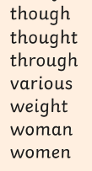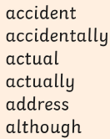  I included a full list of year 3/4 spellings last week for you to assess and work on. If you know them all let me know and I will send you a year 5/6 list.  Remember that you can use a dictionary to work out the meaning of the words you are unsure of.

Suggested Reading Activities
A reminder: You should all be aiming for at least 20 minutes of reading a day!
There is quite a lot of reading material in the topic packs this week.
Topic areas
 | Activities |  | Resources
Science  Scientific research | Read the information on Moths from Topical Tuesday - The Weeks – Junior  Why are the discoveries that the scientists made so important?  Can you make a fact file about Moths from the information given and your own research?  Write an extract for an information text, describing the difference between moths and butterflies. Try and include at least four important distinctions and use contrasting conjunctions such as while, whilst, whereas, conversely, although and however. |  | Article from The Week Junior  Moths
RE: Research | 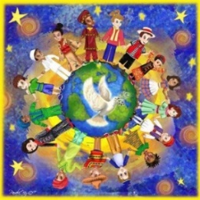Gifts of the Holy Spirit  We know the Holy Spirit visited his gifts on the Disciples at Pentecost.  What do you think this picture is about?  How is the dove linked to the Holy Spirit? Where do we hear of a dove in the Bible?  Read the activity sheet to research the gifts the Holy Spirit bring to us?  How do you use them in daily life? How does using them make you feel? | - Look at the RE activity attached.  - You might like to look at this clip to help you further with your understanding of what God is offering.  It explains what God is offering and how we should try and accept our gifts and thus reap the rewards God offers and that the gifts are there for everyone.  The story explains how a king sent invitations to people, inviting them to a banquet. However, none of the guests turned up, and when asked why, they all made excuses.  The king decided to invite all the sick and poor people instead - all people were welcome who really wanted to come.  https://www.bbc.co.uk/bitesize/clips/zbn34wx
Mini Topic: History  People who have shaped our world.  Florence Nightingale | • The 200th anniversary of Florence Nightingale’s birth was on the 12th May 2020. You will find out why she is considered to be the founder of modern day nursing and learn how the profession has changed since 1850, creating a timeline to show the chronology.  Activity 1  Using the PowerPoint, introduce the name Florence Nightingale. Have children heard her name before?  Slides 4 – 8 introduce information about Florence’s life and achievements. Discuss the information on each slide, pausing for answers to questions asked where appropriate.  Activity 2  Slide 9 asks: How have hospitals changed?  Look at the two images on the slide (also available as A4 pictures). Ask your child to look carefully and discuss what is the same and what is different about the hospital from the 1850s and hospitals today.  Introduce task 1 (shown on slide 10). Children should write a description of  each hospital ward and then write a comparison of the two, stating what is the same and what is different about hospitals then and now using the comparing hospitals worksheet.  Activity 3  Slide 11 asks: How has nursing changed since 1850?  Discuss with your child and see if they can come up with suggestions for how nursing might have changed (uniforms, nurses have more responsibility etc).  Explain task 2, displayed on slide 12. Give your child the history of nursing timeline cards (cut out), and ask them to arrange them so that the events are in chronological order. Then they must read the information carefully to find out how nursing has changed over the time period shown.  Discuss what your child has found out from the timeline. Is there anything that surprises them?  Why do they think there were few men nursing 100 years ago? Do they think this has changed now?  Pupils could draw their own, illustrated timeline using the information.  Activity 4  Slide 13 shows task 3: Would you rather?  Ask pupils whether they would rather nurse in 1850 or today? Pupils should write their answers, explaining why using information learnt from this pack - they can use the themed writing paper.  Activity 5  Share the reading practice text with your child. They should then be able to complete the comprehension questions independently, or you could choose to discuss the answers together.  Activity 6  It would also be really useful to look at the work of Mary Seacole another very important figure in this area and of this period. Clip  What did she do that was so important? What made her do this? What effect did her work have in her time and as a role model now?  https://www.bbc.co.uk/bitesize/topics/zns9nrd/articles/zjsxcqt |  | See all the activities attached
Music  You might like to consider this series of workshops  We have historically taken place as a school | The Bournemouth Symphony Orchestra present a series of activities to find on line that will support your child’s musical development.  ‘These workshops introduce children to making music as they learn to make their own works, take part in warm-up exercises, and rehearse two newly-commissioned nautical songs to commemorate the 400th anniversary of the Mayflower’s pioneering voyage. The project culminates in a group performance. The workshops are designed to support Key Stage 2 curriculum, but can be enjoyed by all ages.’  I have attached the make your own instrument sheets to start you off after you have watched the first workshop on pitch. |  | https://www.youtube.com/watch?v=MDhX-bYqqCg&feature=emb_rel_pause  https://bsolive.com/participate/sea-voyages-hope/  See make your own instruments
Personal /Social and Emotional | Have a look at this assembly.  The NSPCC introduced by Ant and Dec – ‘Speak out and Stay Safe’ |  | https://www.youtube.com/watch?v=qm0kccbZpYY&feature=youtu.be

