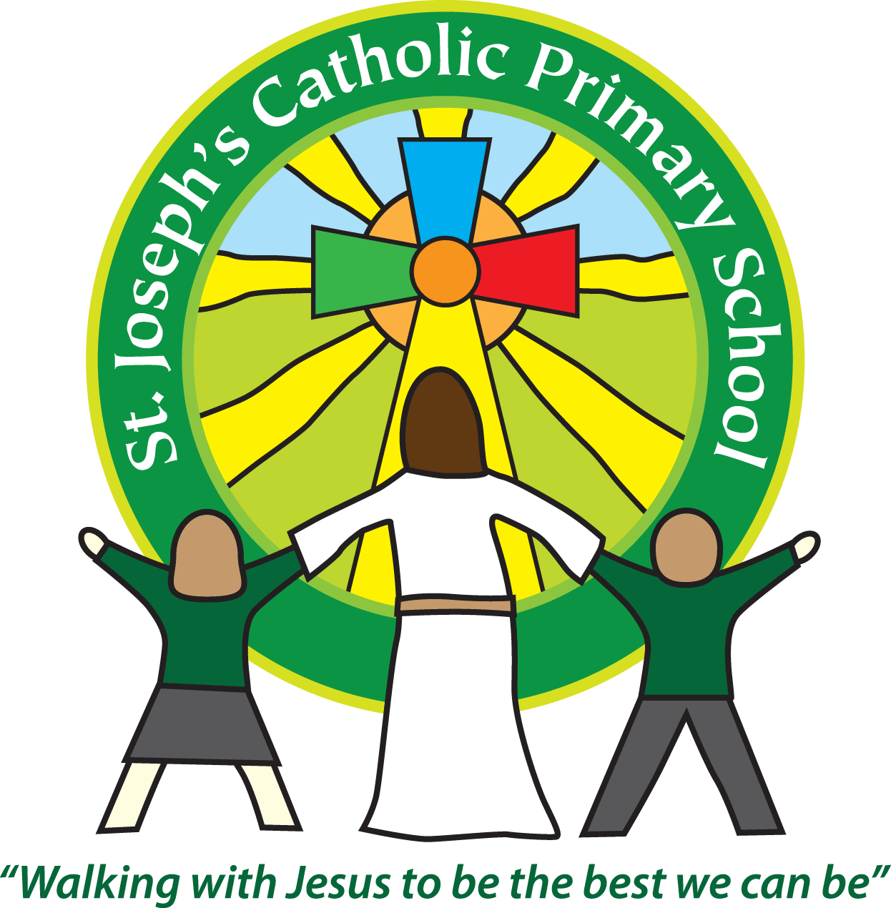

St Joseph’s Catholic Primary School

Newsletter

February 3rd 2017

**Dear all,**

Year 3 have had a very busy week with their parent activity session on Tuesday; thank you to all of you who could attend. Then they performed a super assembly on Wednesday showing us all the great things they have been learning about this term. Well done year 3!

Year 6 have had a demanding week doing some SATs practice papers. Whilst some were apprehensive to start with, we hope that now they have had a go it will remove any anxiety for the real tests in May. Mrs Jukes and I will be giving a SATs talk to all Year 6 parents on Thursday 9th February at 7.30pm. We will be discussing what the tests involve, what we are doing to support your children and ways you can support them at home. Hopefully the timing of the talk makes it easy for parents to drop off their children for the KS2 disco and then join us. We will ensure it is finished by the time the disco ends.

Unfortunately Father Philip had to cancel the Mass on Thursday and I know some of the new Holy Communion children were disappointed about this. Hopefully we will be able to reschedule soon.

**School council**

Last week a couple of our School Council members presented a report to our governors. They talked very eloquently about the great work they have been doing and future projects they are planning. It was also a chance for them to ask the governors questions and to ask for things they feel they might need to help them as a council.

**Breakfast club**

If your child attends breakfast club, from now on when you drop them off please can you go round the back of the car park and knock on the kitchen door where Marie or Carla will let you in. We have changed this for security reasons so thank you for your support with this.

**Bishop Mark visiting**

Next week we are lucky enough to have Bishop Mark visiting St Joseph’s. He will be spending the afternoon chatting with children and staff. It is a good opportunity for the children to meet with him and ask any questions they may have about his role.

**Non-Pupil Day**

Just a reminder that next week – Friday 10th is a non-pupil day.

**Next week:**

Monday: Class 5 swimming

Monday: Class 1 & 2 parent activity session

Monday: Class 1 & 2 cake sale

Thursday: School disco - KS1 6.00pm – 7pm, KS2 7.15pm – 8.30pm.

Thursday: Yr 6 parents SATs talk 7.30pm - 8.30pm.

Friday: Non-Pupil day

**Best wishes and thank you for your continued support**

**Mrs Taylor-Bashford**

**Headteacher’s Awards:**

**Well done to:** Yr 1 –Mischa, Azi, Yr 2 – Callum, Jasmine & Halley, Yr 4 – Louis x2!, Felix, Yr 5 – Carmela x 2!, Oliver, Grace, Jack & Maisie

**Bronze certificates:** FSU – Annie, Yr 1 – Amelie & Niamh, Yr 3 – George, Thomas, Olivia S & Frank Yr 5 – Sophie, Tabitha, Ellie, Connor, Henry, Damon, Yr 6 – Lillie, Shannon, Chanel, Amelia, Scarlett, Benjamin, Edward

**Silver certificates**: Yr 5 – Harry, Yr 6 – William Lavis & Ellori

**Gold certificates:** Yr 5 – Maisie & Finn

**Attendance** **certificates:** Well done to the 107 children who had 100% attendance last term.

**Stars of the Week:** FSU – Max, Yr 1 – Azi, Yr 2 – Emmie, Yr 3 – Olivia S, Yr 4 – Jeff, Yr 5 – Jack W, Yr 6 – Finlay



If you know anyone looking for school places, please let them know we still have spaces available in some classes. They can contact the Office for more information or to book a tour.

Tel: 01395 264875 email: admin@stjo.uk