Strange and Miraculous!
The Story of Pentecost
by Linda Sue Pochodzay Edwards

Tara was looking at the calendar in great anticipation. She was so excited because her birthday was coming up soon, and she just couldn't wait.
"One . . .
two . . .
three . . .
four . . .
ONLY FOUR MORE DAYS!" she squealed with glee.
Then she saw a strange word she had never noticed before. "Pen . . . Pen . . . Pen - te - cost," she slowly pronounced the word. "Hey, Mom. What is this funny word?" she asked, sounding it out again slowly.
"The word is 'Pentecost,'" she explained. "It is the day the Holy Spirit came upon the first Christians, and it is celebrated as the birthday of the church."
Her mother lovingly took her by the hand, led her to their favorite chair, picked up the Bible, and began to tell her the story of Pentecost.

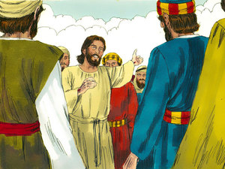
After Jesus arose from the dead that very first Easter Sunday, He spent forty days walking and talking with his closest friends and followers. They were thrilled that Jesus was alive again, and they listened very carefully to every word as He taught them more about the kingdom of God.
One of Jesus' favorite places was on top of a mountain. He would go there often to be alone and talk to God. His friends loved Him so much and didn't want to leave Him. One day some of them followed Him to the top of the mountain. On the way up, Jesus told them that the Holy Spirit would come to give them power to teach people all over the world about Him.
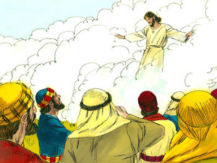
When Jesus finished talking about the Holy Spirit, a very strange, miraculous thing happened. They watched in amazement as a cloud appeared out of heaven. It surrounded Jesus and lifted him up. He disappeared out of their sight. They had never seen anything like that, and they couldn't believe their eyes! They just stood there staring up into the sky!
And that isn't all . . .
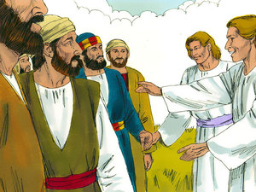
Two ANGELS appeared right beside them, asking why they were just standing there. The angels explained that Jesus had been taken up to heaven, but He would someday come back to earth. They were certainly glad to hear that, but they still didn't know what to make of it all.
This was all quite puzzling, and they weren't exactly sure about what they should do next. One of them remembered the words of Jesus telling them to stay in Jerusalem, so they walked down the mountain, and down the dusty road into the city, talking excitedly about the event that had just taken place.
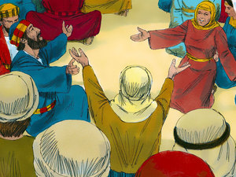
All the disciples and other friends of Jesus gathered in a big room to hear the story of Jesus being taken away in the cloud. They enjoyed each other's company and had meals together. They discussed the things Jesus had told them while He was with them. And most importantly, they prayed together.
It was during one of these prayer meetings that ANOTHER strange and wonderful event occurred.
SUDDENLY, from out of nowhere, came the sound of a rushing mighty wind. It sounded like a huge tornado was right in the room with them!
And that isn't all . . .
They saw something that looked like two flames of fire resting just above each person's head!
And that still isn't all . . .
They were all filled with the Holy Ghost, and they all began to speak in other languages which they had never learned!
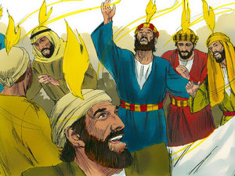
The noise from the wind, and from the praying, and from all the people speaking at the same time was so loud that people outside on the street down below were beginning to wonder what in the world was happening up there in that room!
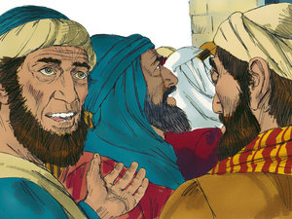
People came from all around to find out what all the commotion was about. They were amazed and thought it was marvelous that they were hearing people speaking in their own language, because they knew that the people in the room were all from Galilee and didn't know any other language except their own.
Some people were thrilled to be hearing about the wonderful works of God. Other people didn't understand and thought the people in the room were just drunk.
Peter stood up and started to preach to all the people standing outside. He explained that no one in the room was drunk and that what they were seeing and hearing was the power of the Holy Spirit.
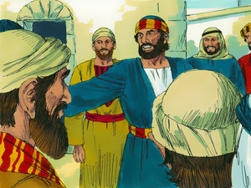
He preached to them about some of the prophecies in the Old Testament.
He preached to them about the teachings of Jesus.
He preached that Jesus was truly the Son of God and they needed to accept Him.
He preached that they needed to repent of their sins and be baptized.
And he preached that if they turned away from their sins and accepted Jesus Christ, they too could receive the gift of the Holy Ghost.

On that ONE DAY, THREE THOUSAND PEOPLE became believers in Jesus! HALLELUJAH!
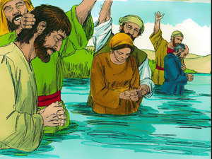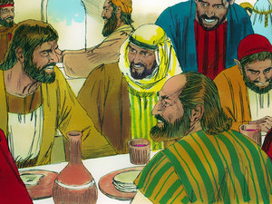
They continued to meet together for meals, fellowship, and prayer, and many other amazing miracles were done through the power of the Holy Ghost!

REMEMBER: The gift of the Holy Ghost is for EVERYONE!

THINK!
1. Why did Jesus' friends stay in Jerusalem?
2. What were the three signs of the Holy Spirit?
3. Who can receive the gift of the Holy Ghost?

