
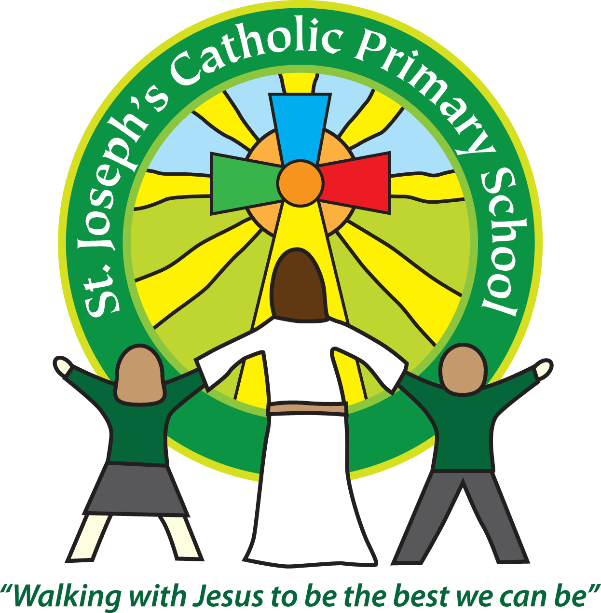

Guidance on Photography in School
Use of Digital Images Policy
This guidance applies to the collection and use of images of any person who can be identified, whether they are a pupil, teacher, other employee, governor, visitor or parent.
For the purposes of this guidance, an image is a still or moving picture of a person who can be identified.
When a school captures a person’s image, whether it is by camera, CCTV, video, web camera or mobile phone, and that person can be identified, then the image is likely to be considered personal data. This means that the image must be processed in line with the data protection principles. ‘Processing’ means anything that is done to the image for example recording it, using it or sharing it.
At St Joseph’s Catholic Primary School we do allow parents to take video and photographs at school events. We follow the Devon County Council guidance which says “When taking photographs, parents do not need to obtain the permission of the other parents in case their child appears in the picture.” However, we do ask parents to respect privacy and so photography at events is on the understanding that photographs that contain images of children other than their own will not be posted on the internet.
We issue parents with a copy of our e-Safety Policy which sets out the use of digital images within school:
- When using digital images, staff should inform and educate pupils about the risks associated with the taking, use, sharing, publication and distribution of images. In particular they should recognise the risks attached to publishing their own images on the internet eg on social networking sites.
- Staff are allowed to take digital / video images to support educational aims, but must follow school policies concerning the sharing, distribution and publication of those images.
- Pupils must not take, use, share, publish or distribute images of others, taken in school, without their permission
- Photographs published on the website, or elsewhere that include pupils will be selected carefully and will comply with good practice guidance on the use of such images.
- Pupils’ full names will not be used anywhere on the school website or any public pages.
- Parents have the right to refuse permission for the school to publish their child’s photo or video image on the school website or in local media and should notify the school, in writing, if they do not want their child’s photo published. Permission is always sought on entry to the school and a record kept.

