St Joseph’s Catholic Primary School Home Learning Pack
Class: Sycamore Year 2 – 01.06.2020
Please find the suggested timetable. This is just a suggestion and you need to find what works for you and your child as we understand that everyone learns differently. Just to be clear, we are not expecting everyone to do all of the activities and these are only suggestions. We understand that our circumstances are all very different at the moment and that lots of you will be trying to juggle ‘home school’ and your own work as well as caring for elderly neighbours and family. Please only do what you feel you can. We do not want to set anything that causes any worry so please do what you feel. There are some references to resources but they do not need to be printed and can be viewed online and the work can be completed or copied onto paper. Please contact us at admin@stjo.uk and in the subject name it… For (Your Child’s teachers name and Class) if you need any further support. For example; For Miss Rowe, Sycamore Class. This will help us to ensure your request is dealt with quickly.
Suggested Family Home Learning Timetable
This is a guide to help you establish a routine for your children – this is just a suggestion and you will need to adapt it to the needs of your family.
Time | Activity
Before 9.00 | Get up, washed, dressed, make beds and eat breakfast
9.00 – 9.30 | PE with Joe or family walk
9.30 – 9.45 | Drink and get ready for home learning
9.45 – 10.30 | English – writing, spelling or grammar activity from your home learning pack
10.30 – 11.00 | Break time - take a snack and drink outside if you can
11.00 – 11.45 | Maths – choose an activity from your home learning pack
11.45 – 12.30 | Creative time – draw, paint, sew, bake, do a job in the garden, stop-motion animation with lego / plasticine (the list is endless). Have a project that you can do a bit of everyday.
12.30 – 1.15 | Lunch – help to make it AND clear up behind it!
1.15 – 1.30 | Chores – do a job around the house e.g. put laundry away, tidy your room, vacuum or polish
1.30 – 2.00 | Quiet time – shared or independent reading
2.00 – 3.15 | Topic time – science / art / history / geography / music – choose a topic activity from the home learning pack
3.00 – 3.15 | Break time – take a snack and drink outside if you can
3.15 – 3.30 | Reading – enjoy a book together

All the PDF’s and resources will be on the school website under Coronavirus – Home Learning – Sycamore.
Maths |  | Activities | Resources
Week 1  Session 1 | Can I use addition and subtraction strategies to answer word problems? | Use the Learning Reminders.  Remember to read through the word problems using RUCSAC.  Read through the problem. Underline or highlight any key words.  Understand the problem. What do you need to find out?  Choose the correct method. Is it +? -? x? ÷?  Solve the problem. Think about the strategy that you will use.  Answer the question.  Check your answer using the inverse. Remember that – is the inverse of + and ÷ is the inverse of x.  Work through the activities. | Maths Resource Session 1
Session 2 | Can I add two 2-digit numbers using partitioning? | If you can access the Powerpoint, work through this. If not, don’t worry as the Learning Reminders are the same.  Work through these and complete the activities. Use the place value cards to help you. | Powerpoint Session 2  Maths Resource Session 2
Session 3 | Can I choose a strategy to add two digit numbers? | In the session above, we revisited partition addition. We have also used a numberline before to add 2 digit numbers. Today’s activities are about selecting which strategy to use.  Work through the Learning Reminders and choose the strategy that works best for you to complete the activities. | Maths Resource Session 3
Week 2  Session 4 | Can I write my own multiplication word problems? | Read through the Learning Reminders.  Work through the activities. Create your own word problems for the arrays. Take care when writing these as word problems. Make sure that they make sense and are clear for whoever would be solving them.  If you want to send me some to work out, you can! Remember to send it to admin@stjo.uk. | Maths Resource Session 4
Session 5 | Can I write division word problems? | If you can access the powerpoint, then work through it. If not, don’t worry because the Learning Reminders are the same. Work through these and complete the activities.  Today, again you are making these into word problems. This makes the Maths real. Remember to make the word problems clear. | Powerpoint Session 5  Maths Resource Session 5
Session 6 | Can I recognise multiplication or division word problems? | Read through the Learning Reminders for today.  It may be useful to recap what you have already looked at throughout the other sessions.  Complete the activities. For this session, you have to decide if it is a multiplication or division problem so remember to use RUCSAC to help you. Think carefully, about the Maths vocabulary that has been used. How do you know that you need to multiply? How do you know that you need to divide? | Maths Resource Session 6

English |  | Activities | Resources
Week 1  Session 1 | Can I plan a story? | Read the Wild Pets story.  Answer the questions about the story.  Use the story planner example to plan your own story based on the Wild Pets resource. | Wild Pets Resource  Learning Resource Session 1
Session 2 | Can I use the possessive apostrophe? | Re-read the story.  Copy down any phrases in the story which show a possessive apostrophe. A possessive apostrophe is used to show when something belongs to someone.  Work through the Possessive Apostrophe Activity.  Next, use your story planner from yesterday to write your own story. | Wild Pets Resource  Learning Resource Session 2
Session 3 | Can I create expanded noun phrases? | Look at Powerpoint 1 and 2 to remind yourself of adjectives (describing words) and nouns (person, place, object) and how to created expanded noun phrases. Powerpoint 2 will remind you of prepositions.  Design your own monster and create some expanded noun phrases to describe it. Then add a preposition to create interesting sentences. | Powerpoint 1 and 2 for Session 3
Week 2  Session 4 | Can I answer questions on a non-fiction text? | Work through the activities in today’s session.  There are some words that you are probably unfamiliar with. Ask an adult to help you if you are unsure. | Session 4 Resource
Session 5 | Can I write a recipe? | Read Animal Recipes together.  Look at how instructions are set out. What features can you recognise? (bossy verbs, numbered steps, adverbs)  Recap Bossy Verbs – These tell you to do something. For example, Draw, Cut, Take.  Work through the activities.  Write your own set of instructions. | Session 5 Resource  Animal Recipes
Session 6 | Can I recognise different verbs? | Read through the What to do today information.  Work through the information on the simple and progressive forms of verbs. Make sure you understand the examples before you move onto the activity.  Work through the activities. | Session 6 Resource

Suggested Reading Activities
Reading Daily
Please enjoy a bedtime story together each night.
Below are some questions that you could explore with your reading.
What do you think the word……………….means? Why do you think that?
Can we work out how ………………………………feels about…………………………….?
Do you have any questions about the text?
Can you compare this story to any others that you have read?
Spellings
Here are a list of the weekly spellings.
You could quiz them each week, like we do in class if you would like to.
Set A
- station
- fiction
- motion
- national
- section
- addition
- subtraction
- option

Set B
- January
- February
- March
- April
- May
- June
- July
- August
- September
- October
- November
- December

Varied activities of Science, Music, Topic (History, Geography, Art) and R.E
 |  | Activities | Resources
Session 1 | Can I research? | This is another whole school Science Activity so you can do it with your family if you would like.  This week, it is about healthy eating. Download the document and follow the instructions. | Science Task 5 Research Document
Session 2 | Can I recognise religious words and symbols connected to Pentecost? | Jesus made a promise to the disciples before he ascended into Heaven that he would send the Holy Spirit to them. What is a promise?  This Sunday marked Pentecost Sunday. You can read the story together. You can access this via the Wednesday Word Website http://www.wednesdayword.org/ or if you have a child’s Bible at home, you can share it from there.  When Jesus sent the Holy Spirit, Tongues of Fire appeared above the Disciples heads. The power of the Holy Spirit allowed them to talk in different languages to share the Good news about God to everyone.  The disciples received the Spirit, which was like a new life. They had the gifts to tell people about Jesus.  Pentecost marks the birthday of the Church; people coming together and living and telling people about Jesus.  Design and make a birthday card for the Church; think of the picture on the front. What will the picture tell us about Jesus? What would be the message inside that might help people understand what the message of Jesus is?  What could it include on it?  Try and use the colours red, orange and yellow to symbolise the flames.  You may use the symbols of the Church (a picture of the Church or Cross), symbols of The Holy Spirit (a dove or flames) as well as symbols of a birthday and the number 50.  If you have the materials, you could make the card.  Here are some ideas from the cards that Sycamore Class made last year.  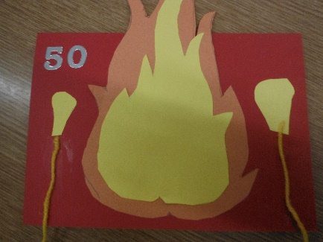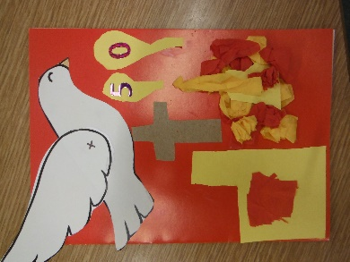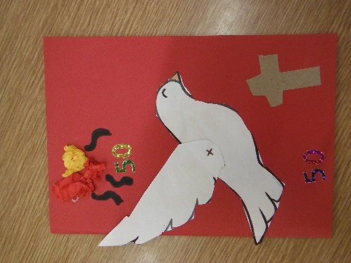 | Card  Pens and pencils  Glue
Session 3 | Can I make observations? | Every time I go out into my garden at the moment, something has changed. I have enjoyed watching the flowers in my garden grow.  Pick a flower or a tree that you can see. If you have a garden, you can pick something from there. If not, take a look out your window, if you can see a tree or some kind of plant, you could use that. If not, perhaps use a plant that you have inside. You might like to plant something and observe how it grows.  Look at it every day for a week. Each day, sketch a picture of it and label any observations that you can see.  Explore how it has changed throughout the week. You could continue this over the two weeks. It will be amazing to closely watch how it changes. | Plant, flower or tree to observe  Paper  Pencils
Session 4 | Can I recognise the life cycle of a plant? | Watch - https://www.bbc.co.uk/bitesize/clips/z3wsbk7  Draw a series of pictures to show the different stages.  Write a sentence for what happens at each stage. Try as use Scientific Vocabulary to explain this process. These words will help you.  - seed  - bulb  - grow  - water  - shoots  - roots  - upwards  - stems  - leaves  - flowers  - germination  - seed dispersal (this is when the seeds are carried by the wind or moved by an animal) | Video link  Pencil  Paper
Session 5 and Session 6 | Can I create an Art Gallery of my family? | For the next two sessions you could create different portraits of your family and make you very own Art Gallery.  You could also draw a portrait of your pet.  A portrait is a picture of a person. The idea is that you create a separate portrait for each member of your family. Don’t forget to include a self-portrait. Or you could ask a member of your family to draw you!  You can find the step by step instructions for the portraits that we created in class with the link below.  https://www.twinkl.co.uk/resource/tf-or-42-we-are-all-different-how-to-draw-a-portrait-step-by-step-instructions  You could paint or colour your portraits with pencil, chalk, felt-tips or pastels. You may want to put your own twist on your portraits like the portraits we studied by Picasso.  When you have finished, remember to label them with who they are at the bottom like a real Art Gallery.  I would love to see any photographs of your portraits. You can send them to me at admin@stjo.uk. | Paper  Pencils, pens, paints

