
St Joseph’s Catholic Primary School Home Learning Pack
Week 1 and 2 - 1st – 12th June
Class: Cherry

Hello everyone,
A little bit of a change to the Home Learning format. The Home Learning will be posted every 2 weeks rather than every week from this point on. I have moved from days to sessions; these may be chronological or not – please check.
Please also keep your eye on ‘The Reading Well’ – our initiative in the promotion of reading for pleasure posted in ‘Other’ within the Home Learning folder in Coronavirus Information on our Website -there is also a previous signposting page for reading in there. I have attached the blog in the Home Learning below to help as well as a reading list of worth while titles for year 3 and 4 reading – if you are in need.
I hope you these two weeks of home learning.
From Mrs Owens

Home learning attachments (for those receiving this as an email)
For home learning during the partial school closure please go to the tab which says Coronavirus information – Home learning, then select the date and class.
Many thanks

Maths | Activities
Mental maths strategies | More revision -  When working out change, 'counting on' from the units should be encouraged, e.g: Change from £1 when spending 67p 3p makes 70p, add another 30p to the 70p to make 100p: answer 33p  Please try some of these at the start of each Maths session.  Try giving change from larger amounts £2 £5 £10 £20 can you go higher? | Resources
Session 1 | Subtraction focus - Find the difference puzzle | See session 1 for activity
Session 2 | Can you use your knowledge of bonds to work out subtraction problems? | See session 2 activities – 2 pages
Session 3 | Choose how to subtract.  Show your method.  When was it important to use a written method or a mental method?  Which is easier for you?  Now try some subtraction of 2 digits from 3 digits e.g. 246-52 = | See session 3 for full explanation
Session 4 | Can I find fractions of numbers?  Have a look at how to find a unit fraction of a number first – PowerPoint for session 4  e.g. ¼ of 12 = 3 so 2/4 of 12 = 6 | See session 4 for full explanation +  PowerPoint session 4
Session 5 | Can I use the bar method to work out fractions of numbers? | See session 5 for full explanation
Session 6:  Times Tables | Have a look https://www.topmarks.co.uk/maths-games/7-11-years/times-tables  to test those tables

English |  | Activities | Resources
Session 1 | Revising and practising word-types |  | See session 1 for full explanation  also PowerPoint for word type revision
Session 2 | Labelling a picture. Making sentences using word types. Writing a story. |  | See session 2 for full explanation
Session 3 | Reading dictionary entries. Using a dictionary. Writing sentences or a story. |  | See session 3 for full explanation
Session 4 | Reading a poem. Answering reflective questions. Reading a poetry collection |  | See session 4 for full explanation
Session 5 | Reading a poem. Revising metaphor and simile. Writing a poem. |  | See session 5 for full explanation
Session 6 | Poetry performance  Choose one poem from the poems you have read over the last two sessions.  Can you memorise it and perform it for your family? |  | See session 6 poetry
Spellings
- Please practise personal spellings = those generated in your work at home x 3 | 2. Please practise each year 3/4 spelling once daily using your preferred learning method  spellings for these two weeks are:  Week 7 Week 8  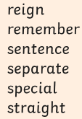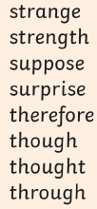

Suggested Reading Activities
A reminder: You should all be aiming for at least 20 minutes of reading a day!

- Please read ‘The Reading Well’ blogs attached which sign post a new JK Rowling story and other good quality literature links
- Please read Good book choices signpost sheet year 3

Topic areas
 | Activities | Resources
Science | What nutrients are in your food?  Main objective: Enquiry type - Research  Scientists use research to investigate their hypotheses (predictions) and answer their scientific questions. In this task we used secondary sources to find the  answer. This enquiry type requires using skills to compare and evaluate information; separating fact from opinion; recognising bias; and an ability to  extract key information. | See Science - Nutrients Research Project
RE  He said to them, ‘Peace be with you’... He breathed on them and said: ‘Receive the Holy Spirit.’” John 20:19-23 | This week we celebrate Pentecost, when the disciples received Jesus’ promised gift of the Holy Spirit, who strengthened them and helped them to be like Jesus.  Please read the account of Pentecost attached  Please reflect on how the Holy Spirit:  - Helps us to be like Jesus  - Inspires us to do good in the world  Can you design a poster that has two halves – one side showing the story of Pentecost and the other showing people receiving the Holy Spirit today – what does that look like?  Prayer for reflection:  Loving God, we give thanks  for the extended family  of local communities  assisting with the needs  of both frail and elderly  confined to their homes.  May every gift of love,  every encouraging word,  bring hope into lonely lives  and a blessing to the giver.  Please find a resource link to more prayers for this season as the one below courtesy of  Ten:Ten resources below  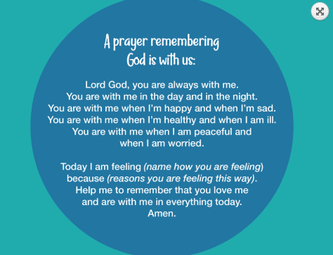  https://www.tentenresources.co.uk/primary-subscription/prayers-for-home/15-prayers/
Mini Topic 1  Rivers Home learning project | This is a cross curricular topic all about rivers with a range of different activities and questions o consider. You will be asked to investigate -  - River features  - UK rivers  - Different river uses  There are also a range of fun river challenges such as make a bridge and an actual river bed…..  You might these sites useful to support your work:  https://www.bbc.co.uk  https://www.topmarks.co.uk/Search.aspx?q=rivers  http://www.primaryhomeworkhelp.co.uk/rivers.html  This project will also support the work started in the last 2 weeks of the first half of the Summer term on the British Isles | See The Rivers home learning project for a range of activities.
Mini Topic 2  Rivers Home learning project continued | See above | see above
Computing 1 | Bare foot Zoo – Abstraction - all you need is……  Make sure you use a nic name when on the site | See computing project sheet  for more information
Computing 2 | Hour of Code  You will use ‘repeat until loops’ and ‘if’ – conditional statements  Make sure you watch the video | See computing project sheet  for more information

