The Reading Well

The latest signpost blog in St Joseph’s reading for pleasure initiative.

To all budding illustrators and readers -
Have you spotted an interesting initiative from the Harry Potter’s Author JK Rowling – read on about ‘The Ickabog’

https://www.theickabog.com/home/

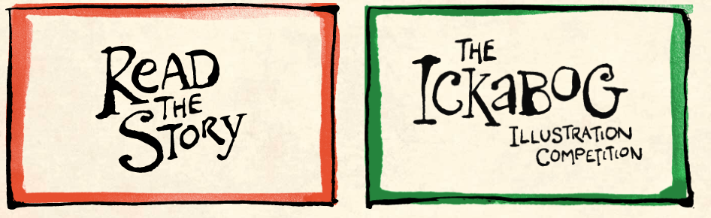

Chapter one and two are now available to read on the web site above. The story is to come out in weekly instalments – there will be 7 weeks in all. There is also a very exciting Illustration Competition in which children are invited to submit there own illustrations to be considered for the book.

Other good quality Literature out there:

https://www.bbc.co.uk/bitesize/articles/z7f7xyc

It tells of a blackbird who is inspired to sing a special song. The idea sweeps around the globe, with creatures on all continents joining in and, eventually, humans too.
A Song of Gladness is one story on The Book of Hopes, a project involving more than 100 well known authors and illustrators. The collection of writings and poems is dedicated to the key workers fighting the Covid-19 pandemic in hospitals and can be seen on the Literacy Trust website.
https://literacytrust.org.uk/family-zone/9-12/book-hopes/ ( Literacy Trust)

Enjoy ☺

Mrs Owens
English coordinator

