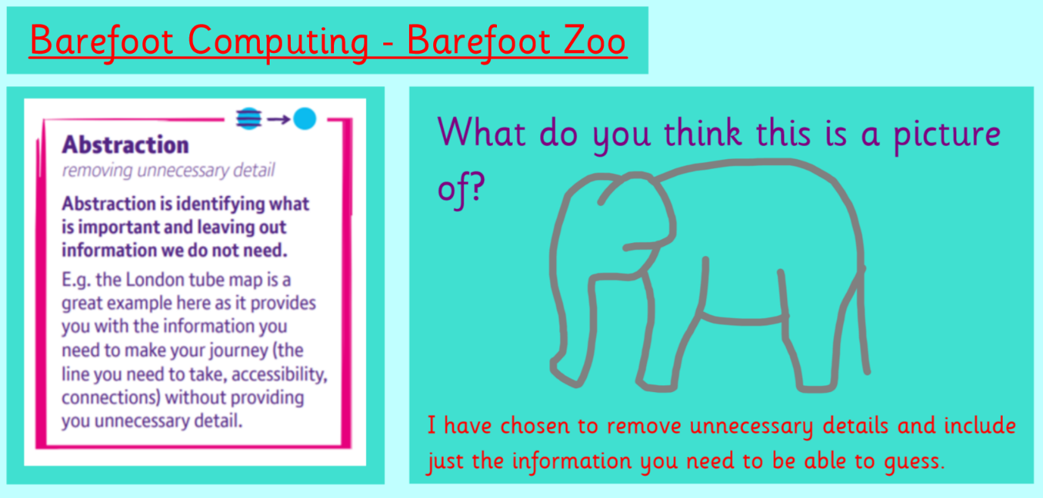

<https://barefootgames.org/barefoot-zoo?ref=https://www.barefootcomputing.org/>

**2.**



**3.**

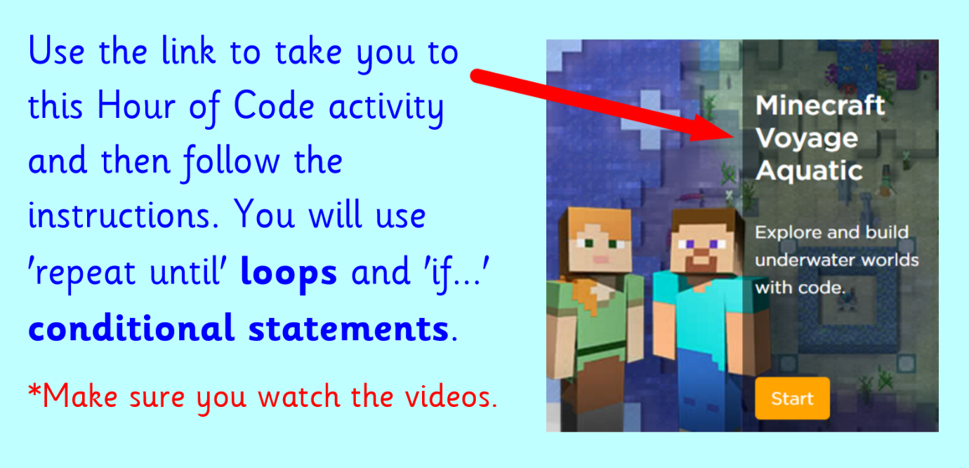

<https://code.org/minecraft>