Home learning
28.02.2020
To be back by Wednesday – 4th please

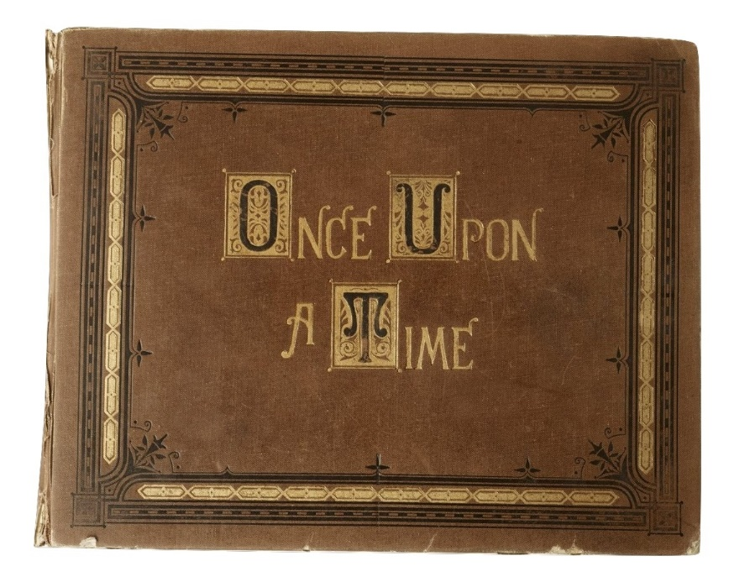

Maths: Play in the Garage on TTRS for at least 15 minutes.
English: Learn and remember a traditional tale to retell to a small group. You may make notes in your home learning book if you wish to
Spellings:
- strange
- strength
- suppose
- surprise
- therefore
- although

Practise spelling the six words above using your chosen method. Can you put each word into a sentence?
Parents can you sign and date to confirm that your child has completed their spellings and practised their times tables.

_________________________________________

