Can I solve word problems involving multiplication?
Marvellous
- Eight aeroplanes each carry 157 passengers. How many passengers can the eight aeroplanes carry altogether?
- Mrs Tomlinson, the school cook, wanted to give each child 4 sandwiches for their school trip. There are 974 pupils in the school. How many sandwiches will she need?
- There are 7 sweet stalls at the market. If each stall sold 1235 sweets, how many sweets would be sold altogether?
- There are 28 children in Year 5. Each child is given 12 Gospel Value Points. How many points are given in total?
- Mrs Jukes bought 12 packets of chocolate digestive biscuits. If there were 35 biscuits in each pack, how many biscuits did she buy altogether?
- A stand in a sports stadium has 245 rows of 87 seats. How many seats are in the stand?
- Mr Malik is saving up for a new car. He saves £1345 each month and saves for 12 months. How much money has he saved altogether?

Magnificent
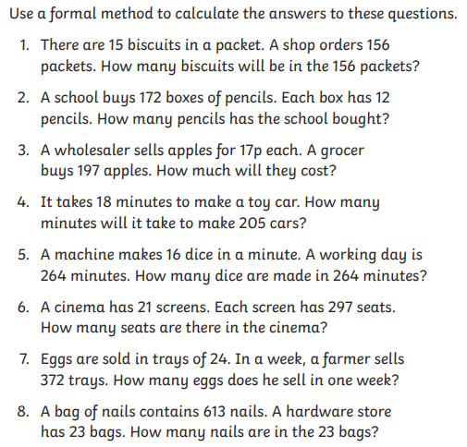

Mind-blowing
Use a formal written method to calculate the answers to these questions:
- A wholesaler sells pineapples for 96p each. The wholesaler sells 3990 pineapples in one week. How much money will the wholesaler receive for the pineapples?
- A crate of screws contains 5193 screws. A DIY chain store orders 52 crates for all its stores – how many screws have they ordered in total?
- A rugby club has an average attendance of 6962 people to each match. What is the total attendance for the 39 matches played in a season?
- There are 17 biscuits in a pack and 3 packs in a box. A supermarket order 15, 379 boxes. How many biscuits will there be in 15,379 boxes?
- A factory makes nine crates of 38,628 pencils on each of the 5 working days of a week. How many pencils are made in a week?
- There are 22 children on a school visit to France. Each child pays £333.18 for the trip. How much do they pay altogether?

Answers
Fluent in Five: 1) 16 2) 7 3) 3393 4) 13 5) 12

Marvellous: 1) 1,256 passengers 2) 3,896 sandwiches 3) 8,645 sweets 4) 336 points 5) 420 biscuits 6) 21,315 seats 7) £16,140

Magnificent: 1) 2,340 biscuits 2) 2,064 pencils 3) £33.49 4) 3,690 minutes 5) 4224 dice 6) 6,237 seats 7) 8,928 eggs 8) 14,099 nails

Mind-blowing: 1) £3,830.40 2) 270,036 screws 3) 271,518 people 4) 784,329 biscuits 5) 193,140 pencils 6) £7,329.96

