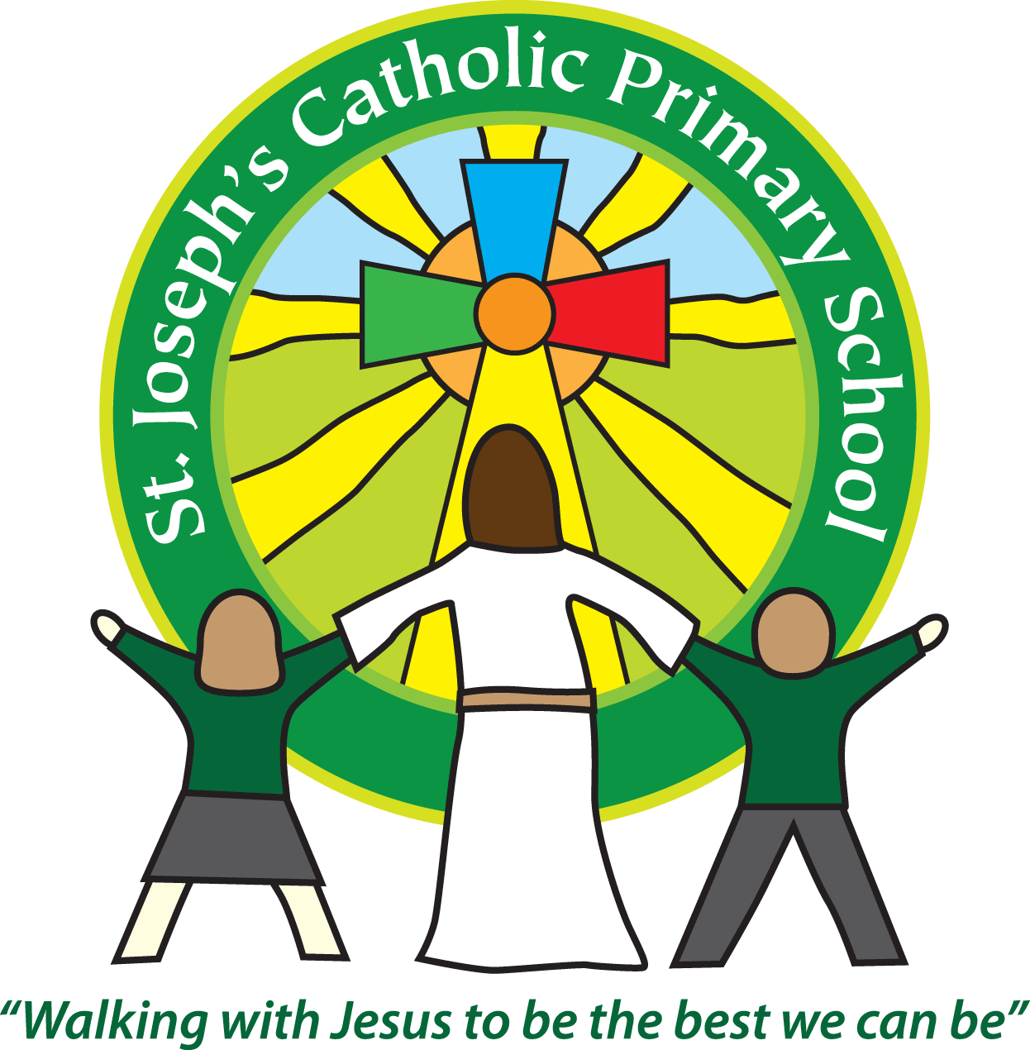

St Joseph’s Catholic

Primary School

Newsletter

June 24th 2016

**Dear all,**

It has been a busy week here. Year 1, 2, 3 and 4 all had their parent activity sessions. Thank you to everyone who could join us. I have received lots of positive feedback about these sessions and we will aim to run one in each class every term. The year 6’s went to ‘Hit the surf’ on Tuesday, where they had a fantastic afternoon at the beach learning all about water safety.

**Reminders:**

Unfortunately we are still having children arriving at school and being left unsupervised before 8.45am. Whilst the gates open at 8.30am there is no adult supervision until 8.45am. If your child is on the school premises before 8.45am without an adult they will be taken to breakfast club and you will be charged.

Next week **(Tues 28th)** sees the **last after school cricket club** of the term. Many thanks to all involved, the children have thoroughly enjoyed it.

This **Wed (29th)** at 6pm we have Kate from Cosmic IT coming in to give a talk to parents about **‘Keeping your child safe online’.** It would be good to see as many people there as possible.

Exmouth Pavilion and Trio Entertainment are putting on The Wizard of Oz Pantomime and are looking for children (aged 7-16) to audition to play parts as munchkins! Auditions are at the Pavilion on 31st July. For more information there is a poster by the School front door.

**Best wishes & thank you for your continued support**

**Mrs Taylor-Bashford**

As many of you are aware, recently, one of our beautiful school mums, Sarah Findel-Hawkins, passed away. We send all of our love and support to her husband Ben and her two children Harry and Emmie.

Some of Sarah’s friends and school mums are taking part in the **Twilight walk on the 9th July** to raise money for Hospice Care. If you would like to sponsor the ladies taking part, please see either Emma Richardson in school or there is a link on Stjos playground Facebook group. If you would like to take part in the walk yourself you can register at <http://www.twilightwalk.org.uk/>

I feel many of the children, staff and community have been affected by a bereavement and would like support with understanding and coping with this. We have Rainbows Bereavement Support group working with us as a school. They are coming to do more training with some of our members of staff and they are coming to do a workshop with all staff members looking at how we can best support all the children in our care as well as ourselves as staff and friends.

I have also asked Rainbows to come in and give a talk to any parents who would like information on the topic of **‘Helping your child understand and cope with significant changes such as bereavement and loss’**. It is an opportunity for any parents to ask questions and seek advice on how to respond to their children’s questions at home. It is on **July 14th at 6pm**, in the school hall and is for any parents wishing to attend.

**Headteacher’s Awards:** Well done to: Aleksy F2, Evan Yr 3, Jack Yr 3, Laura Yr 3, Madison Yr 3, Jeff Yr 3 (2 awards!!),

**Bronze certificates:** Well done to: Mischa, Freddie, Xanthe FS2, Halley, Max, Frankie Yr 1, Oliwia, Jasmyne, Laila Yr 2, Evan , Jack, Laura Yr 3,

**Stars of week:**. Gina F2, Orla Yr1, Jack Yr 2, Scarlett Yr3, Alex Yr 4, Alana Yr 5, Ethan Yr 6





