**St Joseph’s Catholic Primary School**

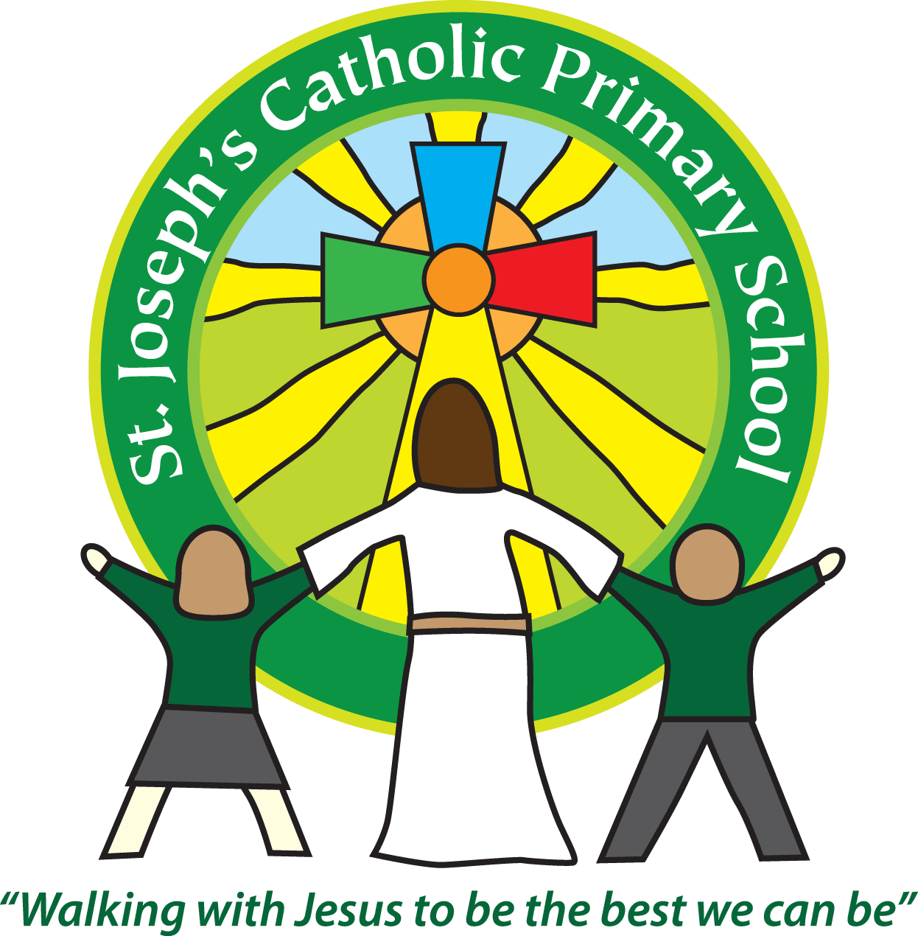

**Year 1 – Summer (2nd half)**

Welcome back everyone, we hope you have had a lovely sunny half term break. Only half a term left together now, but it’s going to be a great one! Thank you once again for all the support you have given to your child’s learning at home. It really does make a huge difference!

This half term our topic is: ‘**Homes from History**.’ We have a school outing to Powderham Castle coming up with Mrs O’Mahony and a visit to the Estuary later on in the term with Mrs Robertson. We also have our Class Assembly on Wednesday 19th June at 3pm where we are looking forward to sharing our learning with you!

Can we please remind you to log into Google classroom **each week.** We are posting homework on there every Friday as well as any other updates.

We noticed near the holidays that it seemed that there were some children who were not reading at home. If we can support you with this in any way then please let us know. Reading is such an important part of Year 1. The ideal is for children to be reading **5x a week**. It may just be a couple of pages, but it really makes a huge difference. If you are unable to access your ebooks, then please let us know.

As the weather is getting warmer, could we ask that all children come with named hats and water bottles. Sun cream should be applied before they come into school.

We are all looking forward to an exciting final term together in Rowan Class!

Please see attached our topic overview.

**Year 1 home learning**

|  |  |  |
| --- | --- | --- |
| Subject |  | |
| Reading | Friday | We expect the children to read at home daily. Daily practice can really support your child’s progress, even if it is just for five minutes every day. Thank you for your support with this. Books will be added on a **Friday** each week. As part of your reading routine, you can support your child by asking questions about the book. E.g How is Lucy feeling when …….? What do you think will happen next? Can you discuss your favourite words and phrases? |
| English/Maths/Topic/  Spelling | Friday | Parents often ask about how they could further support learning at home, so we put together a  weekly list of ideas. These will be activities that you can choose to use and they will link to what we  have been learning in class throughout the week. Homework will be posted every Friday on Google Classroom. Please share one part of the home learning with us on Google Classroom each week. |

**Reminders**

|  |  |  |
| --- | --- | --- |
| School lunch and snacks | Year 1 children are entitled to a free school lunch every day. Please see the school website for the menu and now order the meals on Parent Pay. You can send a packed lunch if you prefer.  We promote healthy eating at school and so lunch boxes should not contain more than one chocolate snack and one packet of crisps.  Children are welcome to bring fresh fruit or vegetables for a snack at break time.  **We are a nut free school**. We have children with potentially fatal nut allergies in school, therefore no food containing nuts may be sent into school. |  |
| Drinks | Your child must have a named water bottle in school every day. Please only send in water, no juice or fizzy is allowed. |  |
| Uniform | Please ensure all uniform is clearly named.  Grey trousers or shorts, grey skirt or pinafore dress, white or grey socks, grey tights, White polo shirt, Green logo school sweatshirt or cardigan. Warm weather option – green and white gingham dress (dress with shorts instead of skirt is acceptable)  Hair past shoulder length must be tied back – please use plain hairbands in green, black or white, not brightly coloured bows.  Nail varnish is not allowed. School shoes must be black and no heels, trainers or boots. |  |
| PE kit | Green t-shirt with school logo, black shorts, black or navy jogging bottoms and trainers. Ear rings must be removed or covered with tape for PE lessons.  Watches must be removed for PE. PE kit must be worn to school on a **Tuesday and a Thursday.** |  |
| Bags | Reception, Yr 1 and 2 children must have a book bag in school. This is so books can easily be checked and letters put in.  Children can have a bag or rucksack in school, but please avoid the large bulky ones as 30 rucksacks take up a lot of room in the class. |  |
| Mornings | School starts promptly at 8.55am.  Your child will be greeted at the patio gate by an adult. Please only pass on quick messages then, for a longer meeting please make an appointment.  Children and parents arriving after 9.00am will be asked to sign in at the office. |  |
| After school | School finishes at 3.30pm. If someone other than yourself is collecting your child please ensure the office has their details. We will not let them leave unless we are sure they are safe. |  |
| Contact details | Please ensure you contact details and those of other people who may collect your child are always kept up to date. Please see the office asap if you change your phone number or address. |  |

**Teaching assistants:** The teaching assistants who will be working in class with us this term are Miss Preston, Mrs Kerr and Mrs Shapter. Miss Shearman will be with us until 26th June.

**Key Dates for the Diary:**

Class Photos – Friday 7th June

Class Assembly – Wednesday 19th June 3pm

Trip to Powderham Castle – Wednesday 26th June

Reports to Parents – Wednesday 10th July

Trip to Exe Estuary – Thursday 18th July

We recognise the importance of passing information between parents and school so we are available at the start and end of the day if you need to pass on any messages. However, if you would like a longer chat please make an appointment with us. You can also message us on Google Classroom. Yours sincerely, Mrs Robertson and Mrs O’Mahony.