St Joseph’s Catholic Primary School Home Learning Pack – 04.05.2020
Willow Class

Please find the suggested timetable. This is just a suggestion and you need to find what works for you and your child as we understand that everyone learns differently. Just to be clear, we are not expecting everyone to do all of the activities and these are only suggestions. We understand that our circumstances are all very different at the moment and that lots of you will be trying to juggle ‘home school’ and your own work as well as caring for elderly neighbours and family. Please only do what you feel you can. We do not want to set anything that causes any worry so please do what you feel. There are some references to resources but they do not need to be printed and can be viewed online and the work can be completed or copied onto paper. Please contact us at admin@stjo.uk and in the subject name it… For (Your Child’s teachers name and Class) if you need any further support. For example; For Mrs Spinks, Willow Class. This will help us to ensure your request is dealt with quickly.
Suggested Family Home Learning Timetable
This is a guide to help you establish a routine for your children – this is just a suggestion and you will need to adapt it to the needs of your family.
Time | Activity
Before 9.00 | Get up, washed, dressed, make beds and eat breakfast
9.00 – 9.30 | PE with Joe or family walk
9.30 – 9.45 | Drink and get ready for home learning
9.45 – 10.30 | English – writing, spelling or grammar activity from your home learning pack
10.30 – 11.00 | Break time - take a snack and drink outside if you can
11.00 – 11.45 | Maths – choose an activity from your home learning pack
11.45 – 12.30 | Creative time – draw, paint, sew, bake, do a job in the garden, stop-motion animation with lego / plasticine (the list is endless). Have a project that you can do a bit of everyday.
12.30 – 1.15 | Lunch – help to make it AND clear up after it!
1.15 – 1.30 | Chores – do a job around the house e.g. put laundry away, tidy your room, vacuum or polish
1.30 – 2.00 | Quiet time – shared or independent reading
2.00 – 3.00 | Topic time – science / art / history / geography / music – choose a topic activity from the home learning pack

All of the resources for the home learning below can be found at: https://www.stjosephsprimaryschool.com/website/home_learning_04052020/477542 on the Coronavirus information page – Home learning and then select the date and appropriate class.
Maths | Activities | Resources
Times tables | Please continue to practise your times tables everyday this can be done on TTRS or offline through a variety of games and activities. Here are a few ideas to help you:  - Use playing cards – Choose 2 cards at a time and multiply the numbers together and then discuss corresponding division facts.  - Exercise while reciting your times table facts e.g. skipping  - Play times table ping pong – in partners take it in turns to ask each other questions  - Times table bingo – draw a 3x3 grid and choose numbers from the tables – bingo caller to ask multiplication and division question.  - Why not invent your own times table game to play?
Day 1 | Can I recall multiplication and division facts for the 7 times table?  - Read the learning reminders to refresh your understanding of the 7 times table.  - Complete the practice questions  - If you are finding it tricky complete the ‘A bit stuck sheet’.  - Have a go at the investigation to check your understanding. | PDF document ‘Maths day 1’ on the website.
Day 2 | Can I find factors of a given number?  - Read the learning reminders to refresh your understanding.  - Complete the practice questions  - If you are finding it tricky complete the ‘A bit stuck sheet’  - Have a go at the investigation to check understanding | PDF document ‘Maths day 2’ on the website.
Day 3 | Can I read and plot co-ordinates on a grid?  - Go through the power point or read the learning reminders to refresh your understanding.  - Complete the practice questions  - If you are finding it tricky complete the ‘A bit stuck sheet’.  - Complete the questions to check your understanding | PDF document ‘Maths day 3’ on the website.  Power point day 3.
Day 4 | Can I plot co-ordinates on a grid to create a shape?  - Read the learning reminders to refresh your understanding.  - Complete the practice questions  - If you are finding it tricky complete the ‘A bit stuck sheet’.  - Complete the questions to check your understanding. | PDF document ‘Maths day 4’ on the website.
Day 5 | Can I read and plot co-ordinates on a grid?  - Read the learning reminders to refresh your understanding.  - Complete the practice questions  - If you are finding it tricky complete the ‘A bit stuck sheet’.  - Have a go at the investigation to check understanding. | PDF document ‘Maths day 5’ on the website.

Please continue to keep a written diary recording what you have done each day.
English | Activities | Resources
Day 1 | Can I use adverbials in my sentences to add additional information?  - Watch the reading of Zoo by Anthony Browne  - Use the power point or learning reminders to refresh your understanding of adverbials  - Complete the sentences about the zoo adding adverbials  - Think about a day out for you. Talk to someone about a daytrip that you would REALLY like to have. Be as imaginative and fantastic as you want!  - Write about what you would do. Use adverbials in some sentences. | PDF document ‘English day 1’ on the website.  Adverbial power point on the website.
Day 2 | Can I write a persuasive letter?  - Read Zoo Opinion 1. Which of the writer’s points do you think is most powerful? Why?  - Read Zoo Opinion 2. Which of these two pieces of writing do you agree with most? Why?  - Use the Revision Card to remind yourself about adverbials.  - Underline the adverbials in the sentences  - Write a letter to the zoo owner explaining why they need to treat their animals well. | Power point on the website.  PDF document ‘English day 2’ on the website.
Day 3 | Can I find secret strings in poetry?  - Look at the photo: Fox in the Snow. Write some descriptions of this photo. Try to make them as detailed as you can  - Watch the video of foxes  - Read the poem First Fox – Look carefully at the secret strings  - Read the poem Fox – look for secret strings | PDF document ‘English day 3’ on the website.
Day 4 | Can I compare poetry?  - Look carefully at Sea Views. Which of these seas would you most like to watch? Why?  - Write a careful description of what you would see, smell and feel.  - Read Doing Nothing Much.  - Read and think about the Poetry Questions and write some of your answers in clear sentences.  - Read Maggie and Millie and Molly and May. Then read Black Pebble.  - Answer the Seaside Poem Questions to help you to understand the poems.  - Fill in the Compare Frame, to show what is similar about the two poems. | PDF document ‘English day 4’ on the website.  Adverbial power point on the school website.
Day 5 | Can I recognise verbs in poetry?  - Look at the picture: Thunderstorm. Can you imagine being in a storm like that? Write some descriptions of what you would see, here and feel.  - Read Thunder and Lightning. Underline the verbs that have been used in the poem.  - Read That Stormy Night.  - Answer Stormy Night Questions. Write your answers in clear sentences. | PDF document ‘English day 5’ on the website.

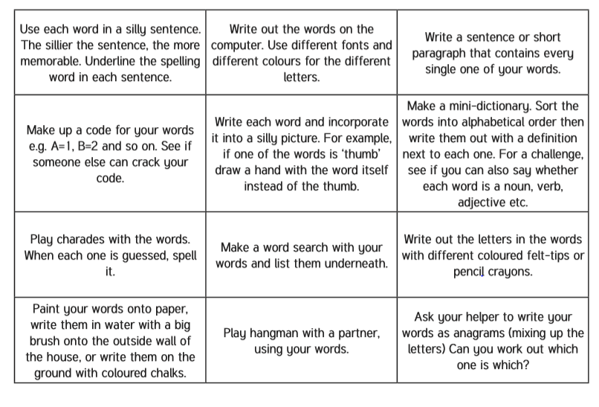
Spelling – Practise the year 4 spellings using a range of strategies. Below are some ideas that you can try.

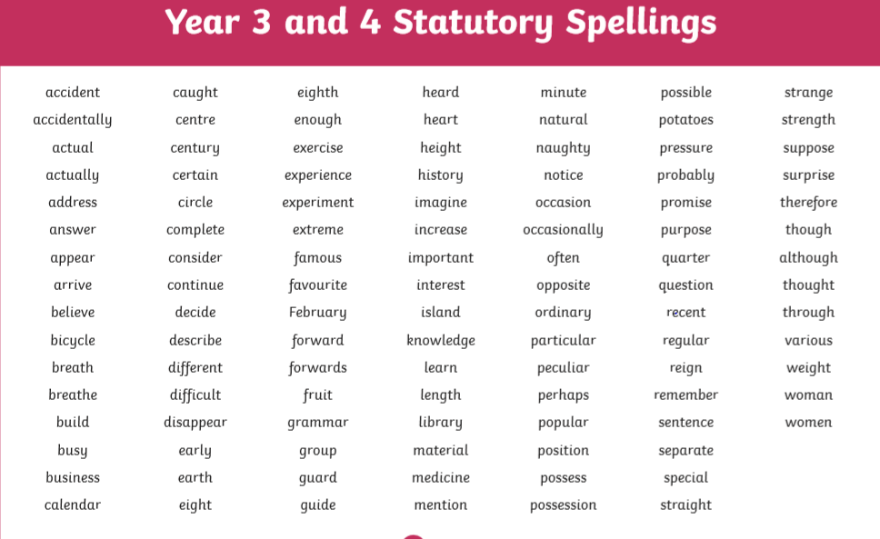
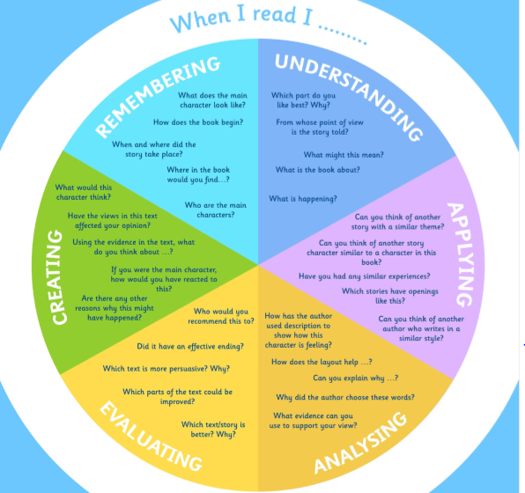
Suggested Reading Activities
This is an essential skill that the children need to continue to practise daily. It is recommended that the children read for at least 20 minutes each day. Continue to record all reading in the reading record books and remember to quiz on accelerated reader. You should have received an email with log in details. Please contact me if there is an issue with this. When listening to your chid read ask questions regularly to check and support understanding. Here is some example questions which would really support the children in their development.

Varied activities of Science, Music, Topic (History, Geography, Art) and R.E
 | Activities | Resources
Activity 1 | This year the children experienced another CAP UK workshop where they were taught to keep themselves safe, strong and free. This booklet reminds the children of this important message through a variety of fun and engaging activities.  Complete the activities in the CAP UK activity pack. | CAP UK activity booklet on the website.
Activity 2 | Can I carry out a fair test?  Make a paper spinner and drop it from a height above the target. Does it land in the center every time? Make sure to only change one thing at a time so that you can see what improved the spinner e.g. the height dropped, number of wings, number of paperclips, size of paper, type of spinner.  Create a poster that explains what you found out.  You could include:  Your equipment  What was easy and hard to carry out  Your result | Task 2 Fair Test on the website.
Activity 3 | Research VE day  Here are some useful websites:  https://www.bbc.co.uk/newsround/48201749  https://www.bbc.co.uk/teach/class-clips-video/history-ks2-ve-day/z7xtmfr  Have a go at writing a diary entry for 8th May 1945 – you could write as a soldier, a child, a teacher  - If you have older members within your family perhaps you could ask them about their experiences. | Diary format on the website. This is a template - you do not need to print it you can make your own.
Activity 4 | Can I design and make bunting to celebrate the anniversary of VE day?  On Friday the 8th May, it is the 75th anniversary of the end of the war in Europe. To celebrate this special day we would like you to design and make some bunting to hang in your window, If you would like to you can send your photo to the BBC as part of their ‘Great British Bunting’ project. Please could you also email admin your photos and state if you give consent for them to be uploaded onto the school website and Facebook page. | https://www.bbc.co.uk/programmes/articles/4TrqYDyf4PMdLypxzyTwGDg/great-british-bunting

