Science Task 1: Enquiry Type - Pattern Seeking

Question
Is there a link between the length of your outstretched arms and your
height?
Take measurements of the people in your house to try and answer the question above. You might measure in centimeters or in the number of pencils long. Once you have measured someone’s outstretched arms and their height, compare the measurements.
How about other body parts? For example, foot length and height, foot and forearm, hand and leg length etc.
Younger Children | Older Children
Create a poster that explains what you found out. You could include:  - your equipment  - what was easy and hard to carry out  - your result | Write a report of your investigation showing your question, prediction, method and results.  When analysing your results, was your prediction correct? How could you have improved the investigation? What other investigations could you carry out?

Challenge | About this type of Scientific Enquiry
Draw a graph to show your results  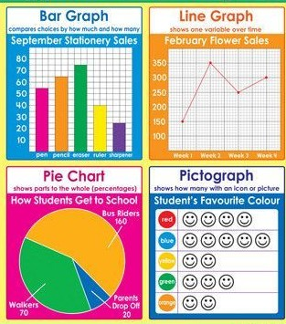 | One of the main types of enquiry that scientists carry out is Pattern Seeking. This is when scientists make observations and measurements and then try to see if there are any patterns or ways to link what they  observe.  Astronomers use pattern seeking to discover new planets and celestial objects.  Sport scientists use pattern seeking to help improve athletes' performance.

