WOW Project 2023

St Joseph's participated in Devon Waste's WOW project (War on Waste). As a school, we are thinking about how our choices impact the world around us - the WOW project helped us to consider how we could protect our environment and natural resources by reducing the waste we send to landfill.

At the start of our project, we ran a waste audit and weighed all the waste collected from around the school in one day. You can see the outcome from our audit in the pie charts below, but we found out that only 14% of our total waste was being recycled. Our aim for the project, was to increase this by at least 10%.

During the year, we promoted recycling and worked hard to reduce our waste. Our Year 6 Eco-champions ran assemblies, made posters and encouraged children to make sure they were putting their waste in the right bins - even the teachers needed reminding! They also wrote a persuasive letter to East Devon District Council to ask if they would consider collecting our fruit waste. The recycling team at the council were very pleased to hear that we were working hard at St Joseph's to help our environment. This is the feedback we received:

“It’s a breath of fresh air hearing about your efforts as a school community to help the environment – thank you and please tell the eco-team to keep up the good work! You must be very proud of them!”

At the end of the year, Hannah from Devon Waste returned to help us repeat our waste audit and we held our breath while we waited to hear the difference we made. We were so excited to receive the news that we had increased the amount of waste being recycled by a massive 37%! This is what Hannah from Devon Waste said:

“A brilliant effort from the Eco Team reducing overall waste across the school and increasing recycling from 14% to 51% - a fantastic result they should be very proud of achieving!”

We are very proud of our achievements as a school and are now planning our next steps towards a greener school.
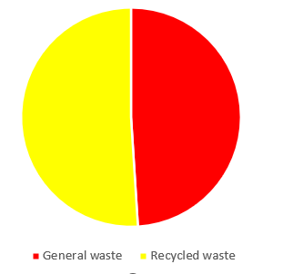
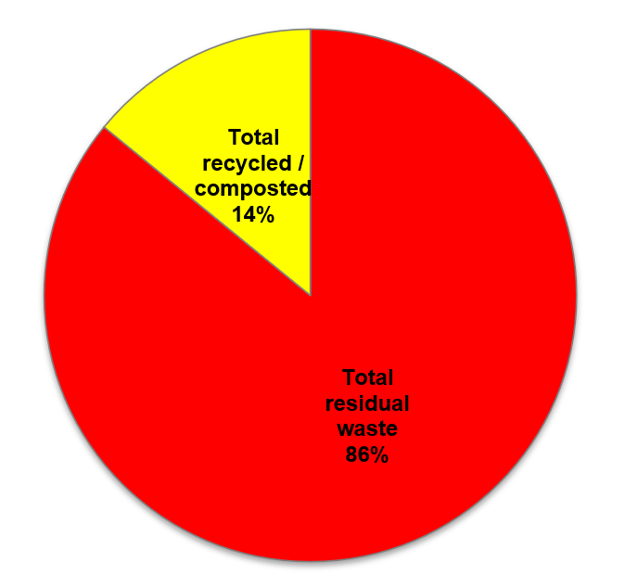
Total recycled / composted 51%
June 2023
October 2022

