St Joseph’s Catholic Primary School Home Learning Pack
Willow Class

Please find the suggested timetable. This is just a suggestion and you need to find what works for you and your child as we understand that everyone learns differently. Just to be clear, we are not expecting everyone to do all of the activities and these are only suggestions. We understand that our circumstances are all very different at the moment and that lots of you will be trying to juggle ‘home school’ and your own work as well as caring for elderly neighbours and family. Please only do what you feel you can. We do not want to set anything that causes any worry so please do what you feel. There are some references to resources but they do not need to be printed and can be viewed online and the work can be completed or copied onto paper. Please contact us at admin@stjo.uk and in the subject name it… For (Your Child’s teachers name and Class) if you need any further support. For example; For Mrs Spinks, Willow Class. This will help us to ensure your request is dealt with quickly.
Suggested Family Home Learning Timetable
This is a guide to help you establish a routine for your children – this is just a suggestion and you will need to adapt it to the needs of your family.
Time | Activity
Before 9.00 | Get up, washed, dressed, make beds and eat breakfast
9.00 – 9.30 | PE with Joe or family walk
9.30 – 9.45 | Drink and get ready for home learning
9.45 – 10.30 | English – writing, spelling or grammar activity from your home learning pack
10.30 – 11.00 | Break time - take a snack and drink outside if you can
11.00 – 11.45 | Maths – choose an activity from your home learning pack
11.45 – 12.30 | Creative time – draw, paint, sew, bake, do a job in the garden, stop-motion animation with lego / plasticine (the list is endless). Have a project that you can do a bit of everyday.
12.30 – 1.15 | Lunch – help to make it AND clear up after it!
1.15 – 1.30 | Chores – do a job around the house e.g. put laundry away, tidy your room, vacuum or polish
1.30 – 2.00 | Quiet time – shared or independent reading
2.00 – 3.00 | Topic time – science / art / history / geography / music – choose a topic activity from the home learning pack

Maths | Activities | Resources
Times tables | Please continue to practise your times tables everyday this can be done on TTRS or offline through a variety of games and activities. Here are a few ideas to help you:  - Use playing cards – Choose 2 cards at a time and multiply the numbers together and then discuss corresponding division facts.  - Exercise while reciting your times table facts e.g. skipping  - Play times table ping pong – in partners take it in turns to ask each other questions  - Times table bingo – draw a 3x3 grid and choose numbers from the tables – bingo caller to ask multiplication and division question.  - Why not invent your own times table game to play?
Day 1 | Can I recognise equivalent fractions?  - Read the learning reminders to refresh understanding of equivalent fractions  - Complete the practice questions  - If you are finding it tricky complete the ‘A bit stuck sheet’.  - Complete the questions to check your understanding | PDF document ‘Maths day 1’ on class web page.
Day 2 | Can I recognise equivalent fractions?  - Got through the power point or read the learning reminders to refresh understanding of equivalent fractions  - Complete the practice questions  - If you are finding it tricky complete the ‘A bit stuck sheet’. | PDF document ‘Maths day 2’ on class web page.  Power point on class web page.  Fractions wall on class web page.
Day 3 | Can I show my understanding of equivalent fractions and decimals?  - Read the learning reminders to refresh understanding of equivalent fractions and decimals  - Complete the practice questions  - If you are finding it tricky complete the ‘A bit stuck sheet’.  - Complete the questions to check your understanding | PDF document ‘Maths day 3’ on class web page.
Day 4 | Can I learn and remember my multiplication and division facts?  - Read the learning reminders to refresh understanding of times table facts.  - Complete the practice questions  - If you are finding it tricky complete the ‘A bit stuck sheet’.  - Have a go at completing the investigation | PDF document ‘Maths day 4’ on class web page.
Day 5 | Can I find the factors of any given number?  - Got through the power point or read the learning reminders to refresh understanding of factors  - Complete the practice questions  - If you are finding it tricky complete the ‘A bit stuck sheet’.  - Complete the questions to check your understanding | PDF document ‘Maths day 5’ on class web page.  Power point on class web page.

Please continue to keep a written diary recording what you have done each day.
English | Activities | Resources
Day 1 | Can I write multi-clause sentences?  - Read Ananse and the Pot of Wisdom  - Summarise the story  - Complete multi-clause sentence activities ensuring secure understanding of verbs and verb phrases. | Power point on class webpage.  PDF document ‘English day 1’ on class web page (story on the document).
Day 2 | Can I show my understanding of conjunctions?  - Read Why Pig has a Short Snout  - Compare to Ananse and the Pot of Wisdom which you read yesterday.  - Summarise the story  - Read the sentences and highlight the conjunctions. | Power point on class webpage.  PDF document ‘English day 2’ on class web page.
Day 3 | Can I write a story using conjunctions?  - Look at the bird illustration and note down what you notice  - Make up a story using the story summary  - Write your story using the conjunctions that you looked at yesterday – Remember to edit and improve your stories. | PDF document ‘English day 3’ on class web page.
Day 4 | Can I read and reflect on poetry?  - Read the four nature poems  - Choose your favourite and answer the questions about your chosen poem  - Practise reading the poem aloud | PDF document ‘English day 4’ on class web page.
Day 5 | Can I retell the Easter story?  - Read the Easter story  - Note down the key points of the story  - Create a story board retelling the story using pictures and written captions. For example: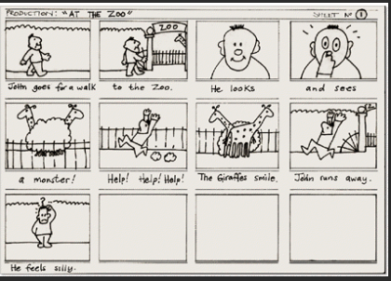 | Easter story: https://www.topmarks.co.uk/easter/easterstory.aspx  www.wednesdayword.org  There is a storyboard template on the class page – you do not have to use this you can draw your own.

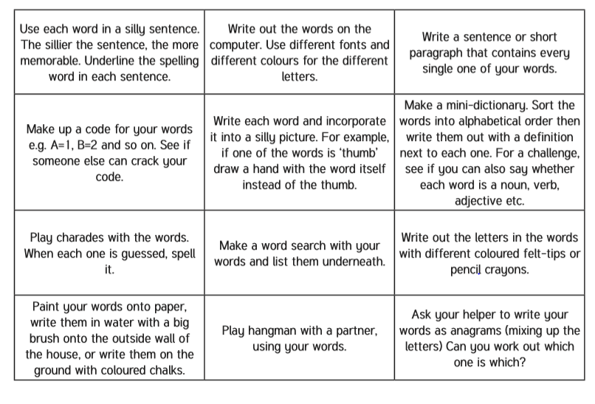
Spelling – Practise the year 4 spellings using a range of strategies. Below are some ideas that you can try.

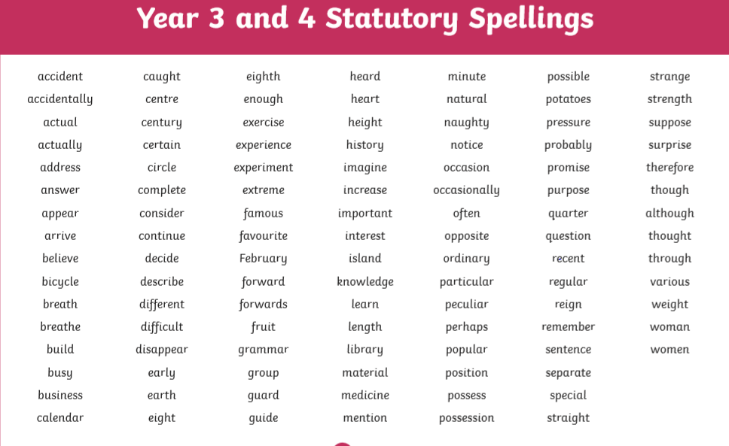
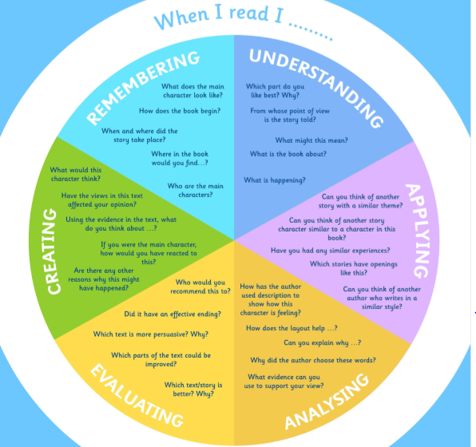
Suggested Reading Activities
This is an essential skill that the children need to continue to practise daily. It is recommended that the children read for at least 20 minutes each day. Continue to record all reading in the reading record books and remember to quiz on accelerated reader. You should have received an email with log in details. Please contact me if there is an issue with this. When listening to your chid read ask questions regularly to check and support understanding. Here is some example questions which would really support the children in their development.

Varied activities of Science, Music, Topic (History, Geography, Art) and R.E
 | Activities | Resources
Activity 1 | Can I create an Easter prayer garden?  One way to think about Holy Week and Easter is to create an Easter garden. Find a space in your garden, or a basket or container. You can use sticks or twigs to make the cross, and a small plant pot to create the tomb.  Find a prayer or write one to say at your Easter garden. | Natural resources from your outdoor area if you have one.  Recycled materials from inside the home e.g. cardboard tubes, yogurt pots  Alternatively, you could make one out of paper
Activity 2 | Can I compare Carnivore and Herbivore teeth?  -Research Carnivores and Herbivores focusing on their teeth and diet  -Draw and label a set of Carnivore teeth and Herbivore teeth  -Compare and explain the differences | Useful links: https://www.bbc.co.uk/bitesize/topics/zn22pv4/articles/z846gdm
Activity 3 | Can I make a food chain?  Look up different food chains  Follow the instructions on the website to create a food chain. You do not have to print the pictures you could draw them and colour them in. | You will need:  Paper  Tape/glue  Colouring pencils/pens  Scissors  Food chains power point on class web page  Instructions:  https://www.science-sparks.com/simple-food-chains/  Food chain games:  https://www.bbc.co.uk/bitesize/topics/zbnnb9q  Video clips:  https://www.bbc.co.uk/teach/class-clips-video/science-ks2-ks3-food-chains-and-food-webs-in-animals/zn7g92p
Activity 4 | Can I design an Easter Egg using patterns from around the world?  Create an Easter Egg template by drawing around an oval object in your home. Research different patterns from a range of countries and design and decorate your template using the patterns. Write some information and facts about the country in a caption below your Easter Egg. | https://cafod.org.uk/Education/Kidz-Zone

