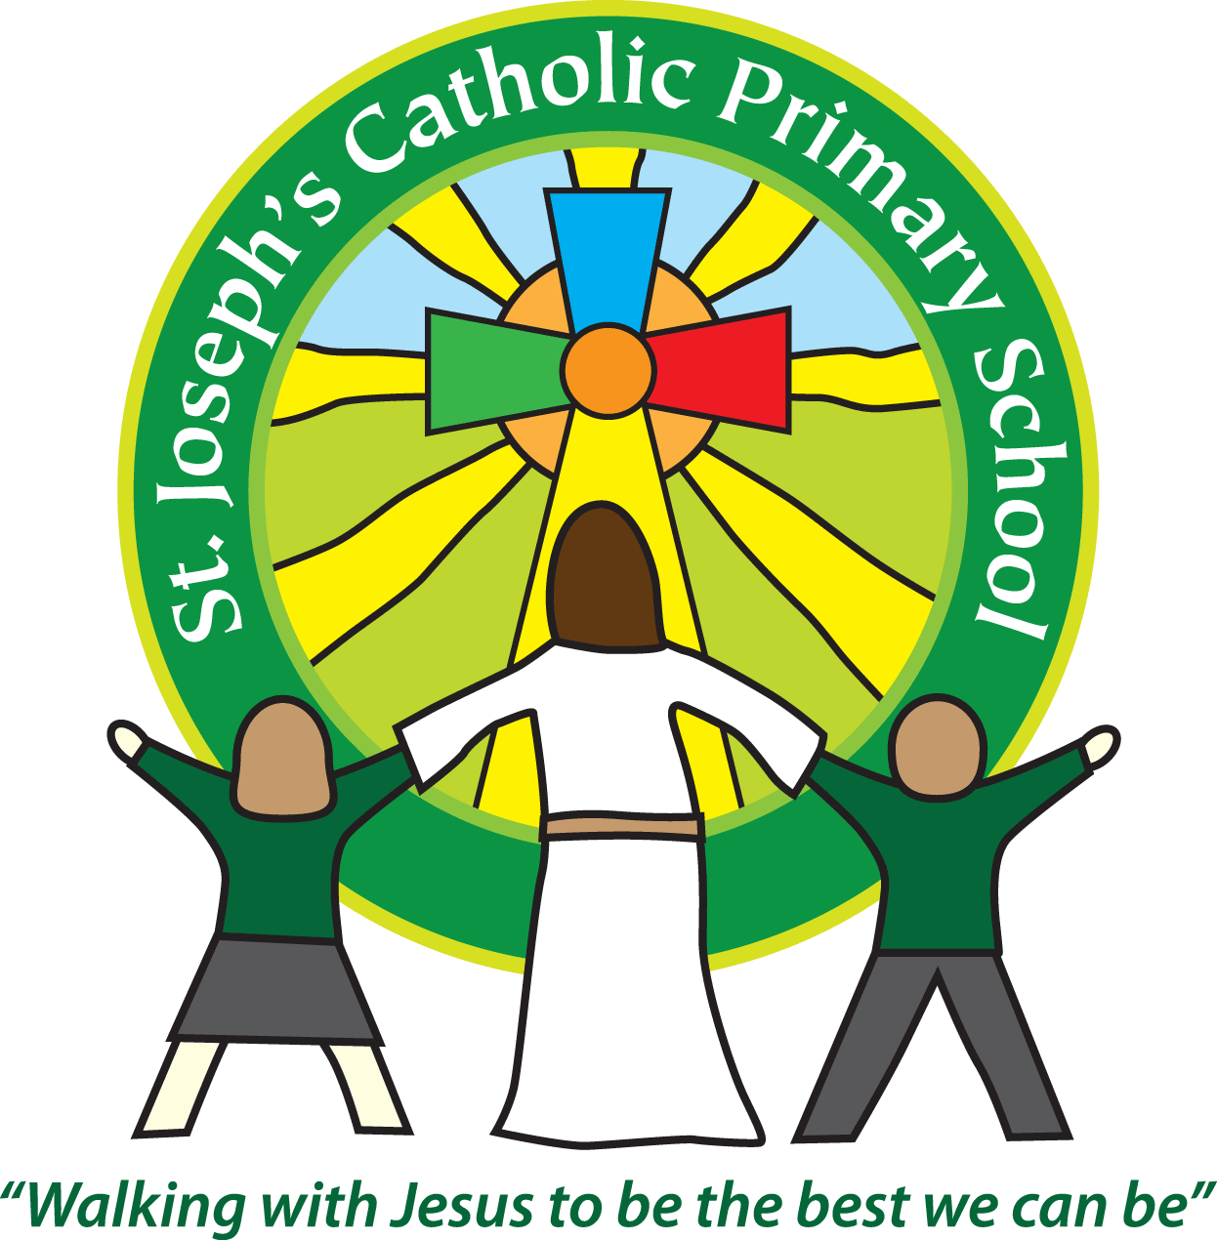
St Joseph’s Catholic Primary School Home Learning Pack
Class: Maple
Please find the suggested timetable. This is just a suggestion and you need to find what works for you and your child as we understand that everyone learns differently. Just to be clear – we are not expecting everyone to do all of the activities. We understand that our circumstances are all very different at the moment and that lots of you will be trying to juggle ‘home school’ and your own work as well as caring for elderly neighbours and family. There’s very little that needs to be printed out – lots of the resources can be viewed online and the work completed on plain paper. All resources have been uploaded to the school website under the ‘Coronavirus Info’ tab. If you need further support, please contact us at admin@stjo.uk and in the subject name type: For Mrs Jukes, Maple Class. This will help us to ensure your request is dealt with quickly.
Suggested Family Home Learning Timetable
This is a guide to help you establish a routine for your children – this is just a suggestion and you will need to adapt it to the needs of your family.
Time | Activity
Before 9.00 | Get up, washed, dressed, make beds and eat breakfast
9.00 – 9.30 | PE with Joe or family walk
9.30 – 9.45 | Drink and get ready for home learning
9.45 – 10.30 | English – writing, spelling or grammar activity from your home learning pack
10.30 – 11.00 | Break time - take a snack and drink outside if you can
11.00 – 11.45 | Maths – choose an activity from your home learning pack
11.45 – 12.30 | Creative time – draw, paint, sew, bake, do a job in the garden, stop-motion animation with lego / plasticine (the list is endless). Have a project that you can do a bit of everyday.
12.30 – 1.15 | Lunch – help to make it AND clear up behind it!
1.15 – 1.30 | Chores – do a job around the house e.g. put laundry away, tidy your room, vacuum or polish
1.30 – 2.00 | Quiet time – shared or independent reading
2.00 – 3.00 | Topic time – science / art / history / geography / music – choose a topic activity from the home learning pack
3.00 – 3.15 | Break time – take a snack and drink outside if you can
3.15 – 4.00 | Physical Activity – PE with Joe, family walk, yoga, Just Dance (look at Mrs Turner’s suggestions)

Hello everyone! Did anyone see the meteors last week? I did get up very early on Wednesday morning, but didn’t manage to spot any!! This week, our topic lessons are going to be focused on creating a time capsule. We are living in historic times – pupils of the future will be learning about the Corona Virus in school just like we learn about the Plague or the Black Death! So, we are going to create a piece of history which will act as evidence for future historians! Did you read any of Samuel Pepys diaries when you learned about the Great Fire of London in year 2? Well, this week, you are going to be 21st century Samuel Pepys! Students all over the country are doing the same piece of work – it will create an interesting and detailed account of what life was like during the spring of 2020! Have fun!
Mrs Jukes

Maths |  | Activities | Resources
Day 1 | Can I find multiples and common multiples? | Fluent in five (just to get you warmed up):  - 34 ÷ 10  - 4456 – 3137  - 6 + 6 + 8  - 7 x 37  - 720 ÷ 8  ANSWERS for fluent in five questions are on resource sheet for today’s lesson.  More revision this week – today it is multiples and common multiples. All instructions and questions are on the sheet listed in resources.  More help here: https://www.bbc.co.uk/bitesize/articles/zfchpg8 (including a Supermovers Dance Routine!) | Maths_Wk3_Day1.doc this resource has been uploaded to the school website.  Choose Marvellous / Magnificent / Mind-blowing as we would in class.
Day 2 | Can I find factors and common factors? | Fluent in five:  - 547 ÷ 10  - 34 x 7  - 4 + 9 + 1  - 432 ÷ 7  - 12.71 + 1.4  ANSWERS for fluent in five questions are on resource sheet for today’s lesson.  Today is all about factors! All questions and instructions on resources sheet listed. | Maths_Wk3_Day2.doc  this resource has been uploaded to the school website.
Day 3 | Can I use formal written methods for multiplication? | Fluent in five:  - 384 + 7  - 4326 – 1138  - 8 + 6 + 8  - = 743 ÷ 7  - 12.4 x 7 (round and estimate first)  ANSWERS for fluent in five questions are on resource sheet for today’s lesson.  You have been using the formal written method for short multiplication since year 4 but long multiplication is new this year. You have had a go in class but need more practice, so here you go! | Maths_Wk3_Day3.doc  this resource has been uploaded to the school website.
Day 4 | Can I solve word problems involving multiplication? | Fluent in five:  - $\frac{1}{3}$ of 48  - 56 = 8 x  - = 4536 – 1143  - 52 ÷ 4  - 2² + 2³  ANSWERS for fluent in five questions are on resource sheet for today’s lesson.  Word problems which allow you to practice your multiplication skills. | Maths_Wk3_Day4.doc  this resource has been uploaded to the school website.
Day 5 | Can I apply my problem solving skills to a range of problems? | Fluent in five:  - $\frac{1}{4}$ of 64  - 3422 – 2721  - 647 ÷ 10  - 873 ÷ 7  - 14.6 x 5  ANSWERS for fluent in five below …  BBC Bitesize Daily. Week 1 Challenges: https://www.bbc.co.uk/bitesize/articles/zfcnscw  Answers for Fluent in Five  - 16 2) 701 3) 64.7 4) 124 r5 5) 73 | BBC bitesize daily  Week 1 – Challenges  See link in activities section.

English |  | Activities | Resources
Day 1 | Can I talk about a poem? | Read the poem, ‘Superheroes I could have been’. Read it out loud to someone in your family. What do you like / dislike about the poem? Can you spot any patterns? Which is your favourite idea for a superhero? (Task 1 on sheet) Can you draw him/her and label your drawing with expanded noun phrases? (Task 3 on sheet) | English_Wk3_Day1  This week’s English resources have been uploaded to the school website.
Day 2 | Can I identify and explore relative clauses? | Using the powerpoint (Relative Clauses) which has been uploaded to the website and the revision cards on English_Wk3_Day1.pdf from yesterday, have a go at Task 2 (Superheroes 1 and 2) | English_Wk3_Day1  Relative Clauses.ppt
Day 3 | Can I use relative clauses in my writing? | Have a go at Tasks 2 (Identify Relative Clauses) and 3 (Invent your Superhero) on the sheet, English_Wk3_Day3  There are lots of real-life superheroes hard at work at the moment – maybe you would like to base your superhero on one of our keyworkers! | English_Wk3_Day3
Day 4 | Can I write emotively about how I am feeling? | Use the ‘Letter to Myself’ template from the Covid-19 time capsule booklet (it is uploaded to the school website. Follow links: coronavirus information / home learning / home learning 27/04/2020 / Maple Class) and write a letter to yourself about your experiences life during lockdown. You could include thoughts and feelings about the good things and the not so good things, the sorts of things you are doing as a family to make the best of the time at home and anything else that you think would be interesting to look back on in the future! This is an opportunity for self-reflection! There’s no need to print the page out – you could just write yourself a letter on any piece of paper. When it is written, check and edit it looking to see if you can make any improvements to spelling and punctuation. Then read it through again and make sure all your sentences make sense – are there any you could improve? Ask an adult to be a ‘critical friend’ and check it through with you. Maybe you could ask your grown-ups at home to write you a letter? | Covid-19 Time Capsule.pdf
Day 5 | Can I explain how dialogue shows character in a text? | Reading Lesson: To Be a Cat by Matt Haig (BBC Bitesize Daily)  https://www.bbc.co.uk/bitesize/articles/zn8bgwx  Have a go at the activities in the link above – scroll down for instructions and the written text (you can also hear the extracts read to you by Maro Itoje).

Suggested Reading Activities
Please, can I encourage you to keep reading (and quizzing if possible) as this is the very BEST thing you can do to support your progress in learning. Read fiction (story) books, newspapers, magazines, comics, non-fiction texts (about real stuff) – anything will help. Got an encyclopaedia at home? Learn a new fact about the world everyday – create a notebook and fill it with interesting facts, adding detail by drawing pictures or researching more about it online. Your brain will soon be the size of Britain!!
You should all be aiming for AT LEAST 20 minutes of reading a day! Mrs Taylor-Bashford has sent links to websites to support you reading at home.
Well done to those of you who have quizzed on AR since 20th March but I can see that lots of you haven’t. Please let me know via email to admin@stjo.uk if you need help getting on to AR from home and I’ll see what I can do!
Spelling
Year 3/4
famous
favourite
February
forwards
fruit
grammar

Year 5/6
especially
exaggerate
excellent
existence
explanation
familiar

Use a dictionary (online is fine) to find out what these words mean, use them in a sentence and use the cover, write, check method to learn how to spell them. Get someone at home to test you like we do in class.

Varied activities of Science, Music, Topic (History, Geography, Art) and R.E
 | Activities | Resources
Day 1 - French | Colours of the Rainbow task sheet. | Colours of the Rainbow and I Spy – French.doc  This resource can be found on the school website.
Day 2 - Science | Science Task 1 – pattern seeking.  An important part of working scientifically is being able to identify patterns in life. Scientists are currently using pattern seeking techniques in order to work out the best way to fight the Coronavirus. We are going to use patterns to help us answer this question: Is there a link between the length of your outstretched arms and your height?  Get the whole family involved with this one because the more data you have, the more accurate your results will be! Phone / FaceTime / Skype etc Granny, Grandad, Aunts, Uncles and get everyone to take some measurements. All the instructions are on the attached sheet. If you have younger brothers and sisters in school, they will have been set the same task, so make sure you help them too! | ScienceTask1_PatternSeeking.docx
Day 3, 4 and 5 – History, PSHE | The whole school will be completing this activity this week. We are living in historic times – pupils of the future will be learning about the Corona Virus in school just like we learn about the Plague or the Black Death! So, we are going to create a piece of history which will act as evidence for future historians! Attached is a document that you can fill out during this time of isolation, which you can look back on later in life! | Covid-19 Time Capsule.pdf

