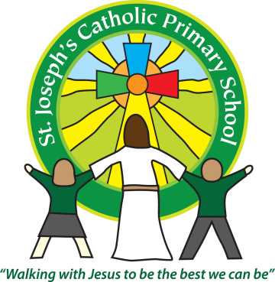


Dear Parents and Carers

Every day we are observing and assessing your children. Some of these observations we upload to Tapestry where you can see which development band your child is working in. At the end of the Reception Year (in June), we will be assessing the children in all areas across the curriculum. One of these areas is Writing, and this is the area where the smallest percentage of children reach the required standard (both Nationally, in Devon and our school). So we need your help at home to practise please!
We thought it would be useful for you to see these examples of writing that are used throughout the country to demonstrate to teachers the required standard.
The Early Years Foundation Stage Curriculum requires us to describe your child’s level of attainment as ‘emerging’ ‘expected’ or ‘exceeding’. Below you will find the description of the expected attainment for children at the end of the Foundation Stage. If your child is ‘emerging’ this means they are currently working towards the expected level of attainment. If your child is ‘expected’ this means they have reached the expected level for their age. If your child is ‘exceeding’ this means they are working beyond the expected level for their age.
The Early Learning goal is:
Children use their phonic knowledge to write words in ways, which match their spoken sounds. They also write some irregular common words. They write simple sentences, which can be read by themselves and others. Some words are spelt correctly and others are phonetically plausible.

Our children are becoming very confident in recognising the letter sounds, so now need lots of practice in recording these sounds and ‘having a go’ at writing.

Things to remember:
● Mark-make outdoors by getting out some chalks, water and paintbrushes are also a great non permanent way for children to make marks or form letters.
● Write notes and letters to your child. This may encourage your child to write a note back and help them see the value of writing.
● Where possible try to find real reasons for children to write, shopping lists, invitations, birthday cards, school registers are very popular.
● You will see from these examples that the words are not always spelt correctly! It does not matter, as long as the children are recording the sounds they hear. Please try not to correct your child’s writing. Children who are corrected too often or asked to write things out ‘properly’ can lose interest in doing it at all.
● Some words like ‘I’ ‘the’ ‘said’ they’ ‘he’ ‘me’ are difficult to spell, so the children just need to practise and learn them! Don’t forget your child can copy these words from a tricky word bookmark until they able to spell them independently.
● Do not encourage your child to copy your writing unless practising actual handwriting. Giving children the opportunity to sound out their own words is a higher level skill and much more important, it does not matter if all the sounds are not there. Spelling usually becomes more accurate as children learn to read.

Happy Writing! Please either bring in your writing or upload it to Tapestry so we can see how you are getting on at home. Many Thanks

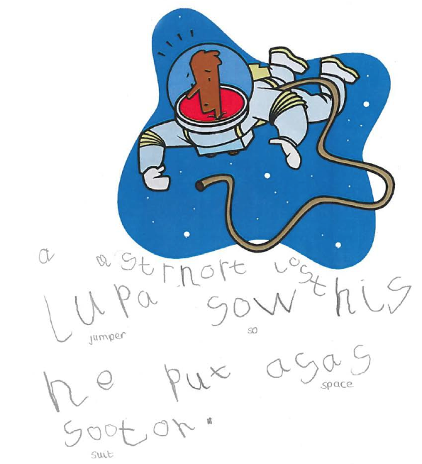
Sarah Keeping Jackie Clarke
