Can I predict what might happen?

Can I observe carefully?

Materials needed
- Skittles® candy in several colours
- Plate
- water
- magnifying glass (optional)

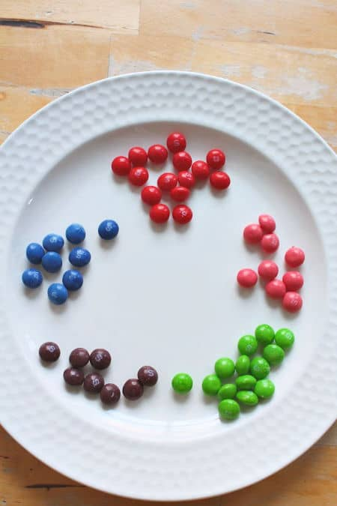

Begin by sorting the Skittles® into colors.

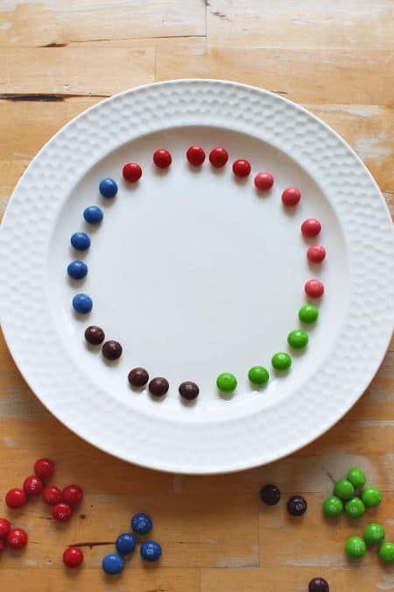

Place the candy around the outside of a plate in a colour pattern. You can choose how many of each colour to use and what pattern to create but use at least 2 or 3 colours.

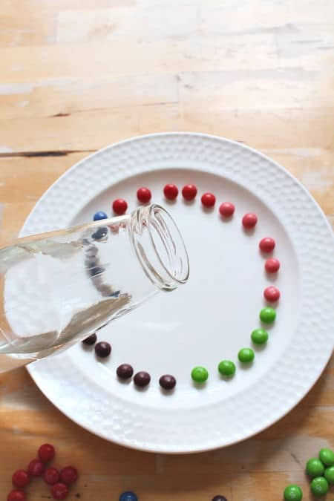

Gently pour water into the centre of the plate. Pour carefully so you don’t cause the Skittles® to move, and until the plate is filled with a shallow layer of water.

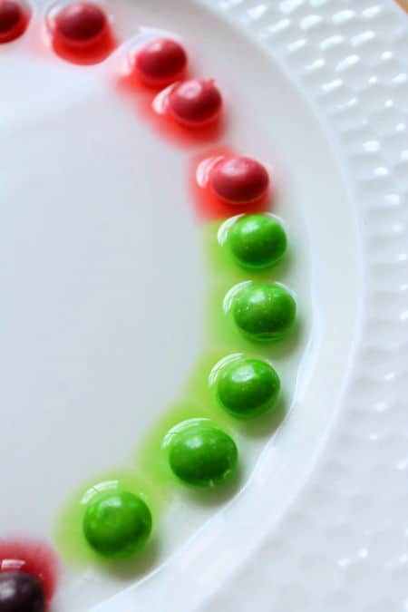

Look closely at the sweets. What can you see happening? You might like to use a magnifying glass to get a close-up look.
You’ll notice the colour of the candy begins to spread into the water.

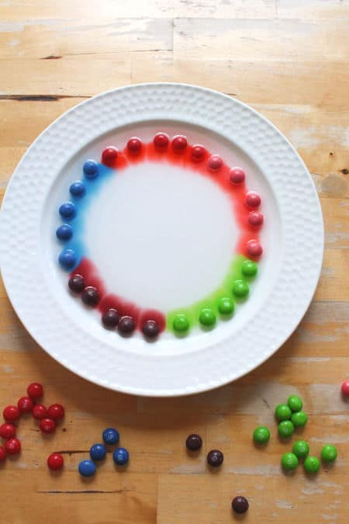

Keep watching and observe how the colour spreads.

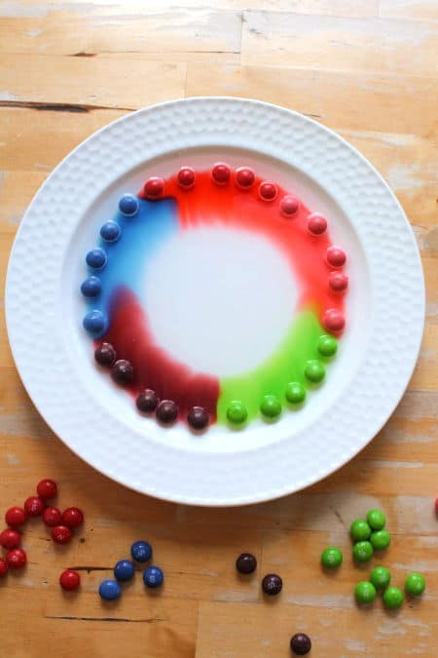

Over a short period of time (just a few minutes) the change increases.

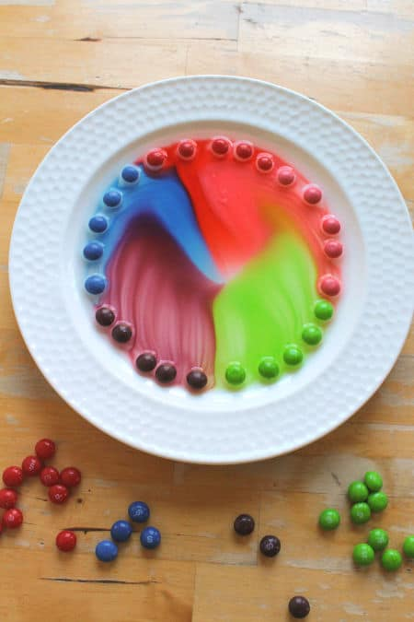

Until soon, the whole plate of water is filled with colour.

Think like a scientist
As you’re watching the water change colour, you can talk about the science behind it. Great science always starts with questions, so encourage your children to wonder.
Maybe they have answers to their questions, maybe they want to alter their experiment to test out their ideas, maybe they want to do some research to get more answers.
All of this wondering and experimenting is developing your children’s minds to think like scientists.
Some ideas to wonder about and test out:
- why does the candy turn the water a different colour?
- do all the candy colours work as quickly?
- what happens if you make a different pattern with the Skittles®?
- what happens if you use a plate that’s a different shape?
- why don’t the colours mix together?
- does this work differently if the water is hot or cold?
- would this work in other liquids?

The science behind the paint
How does this work? Why do the Skittles® make the water change colour? Why don’t the colours mix when they touch each other?
What’s happening is that the food dye, that’s used to give each candy a colour, is quickly dissolving in the water. It absorbs into the water.
Over time diffusion causes the dye to spread through the water from the area of high dye concentration (by the candy) to the area of low dye concentration (the rest of the water).
But why don’t the colours mix when they touch each other? It’s likely because of the concentration gradient.
When diffusion is happening, there’s a net movement from areas of high concentration (lots of colour) to areas of low concentration (no color). As the Skittles® have the same concentration of ingredients in each sweet, when they meet there’s no difference in concentration of sugar or dye. One color doesn’t have more sugar/dye that another, so there’s no flow from high to low. No difference in concentration means no diffusion, which means no colour transfer.

